# **1) Enable CloudTrail monitoring and store the events in s3 and CloudWatch log events.**

1. **Log in to the AWS Management Console:**
2. **Create an S3 Bucket for Storing CloudTrail Logs:** You can use an existing bucket or create a new one. Ensure that the bucket has appropriate permissions for CloudTrail to write logs.

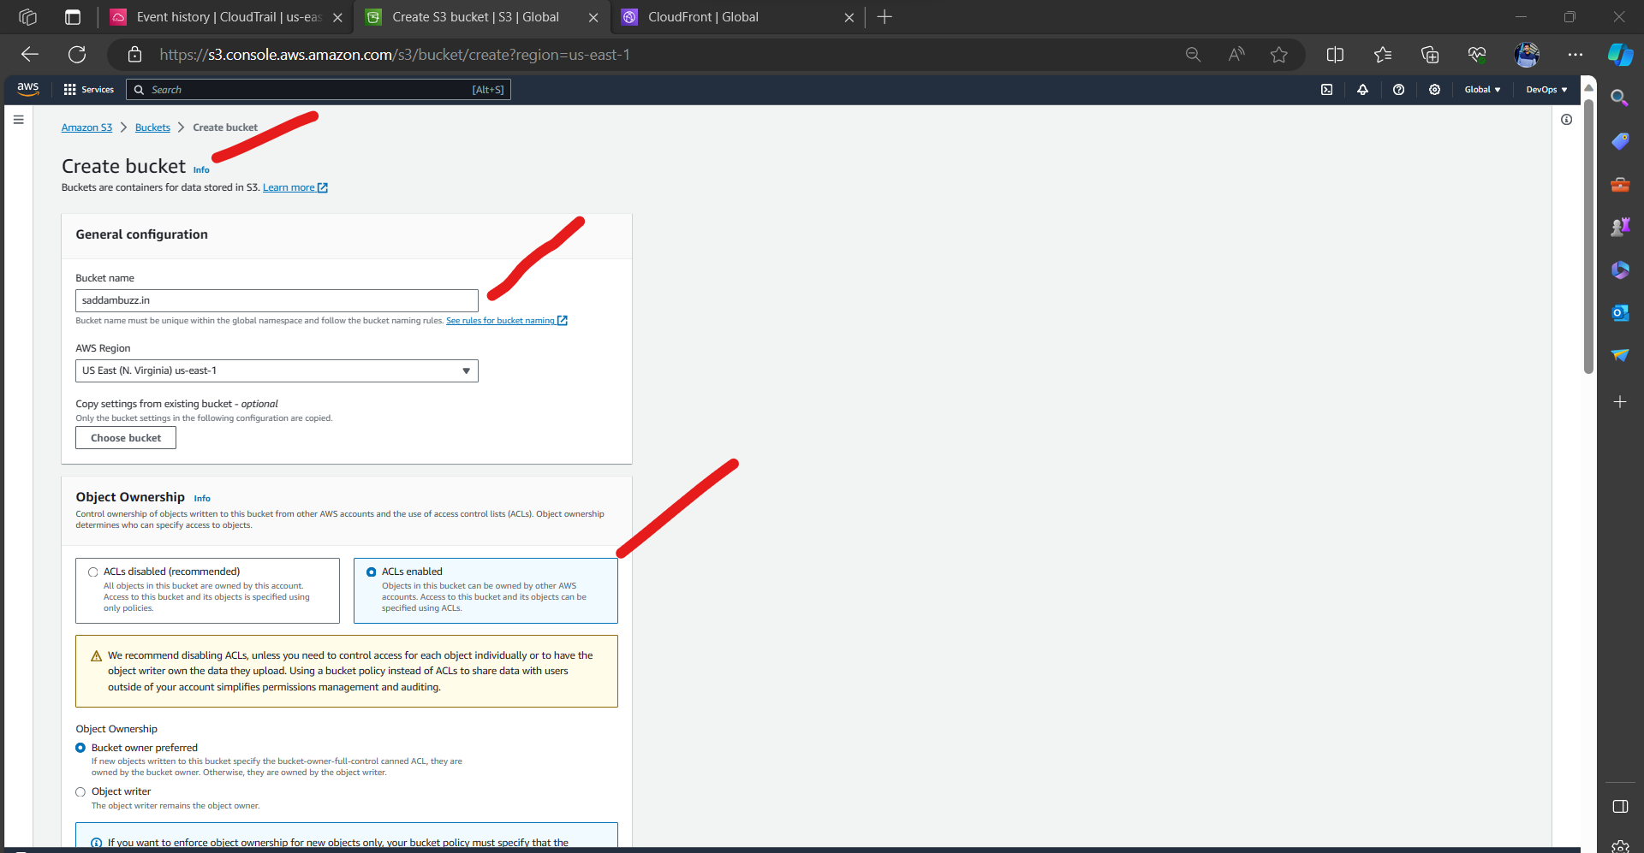

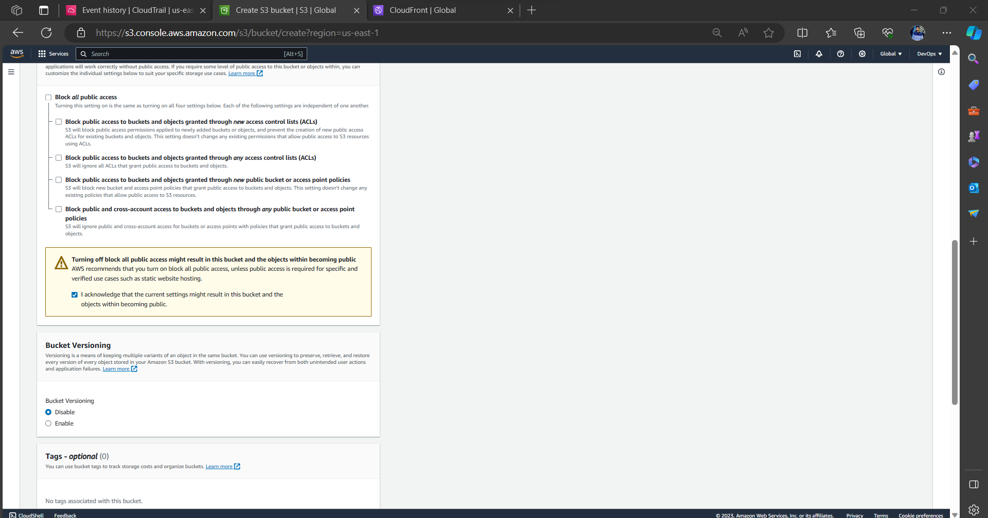

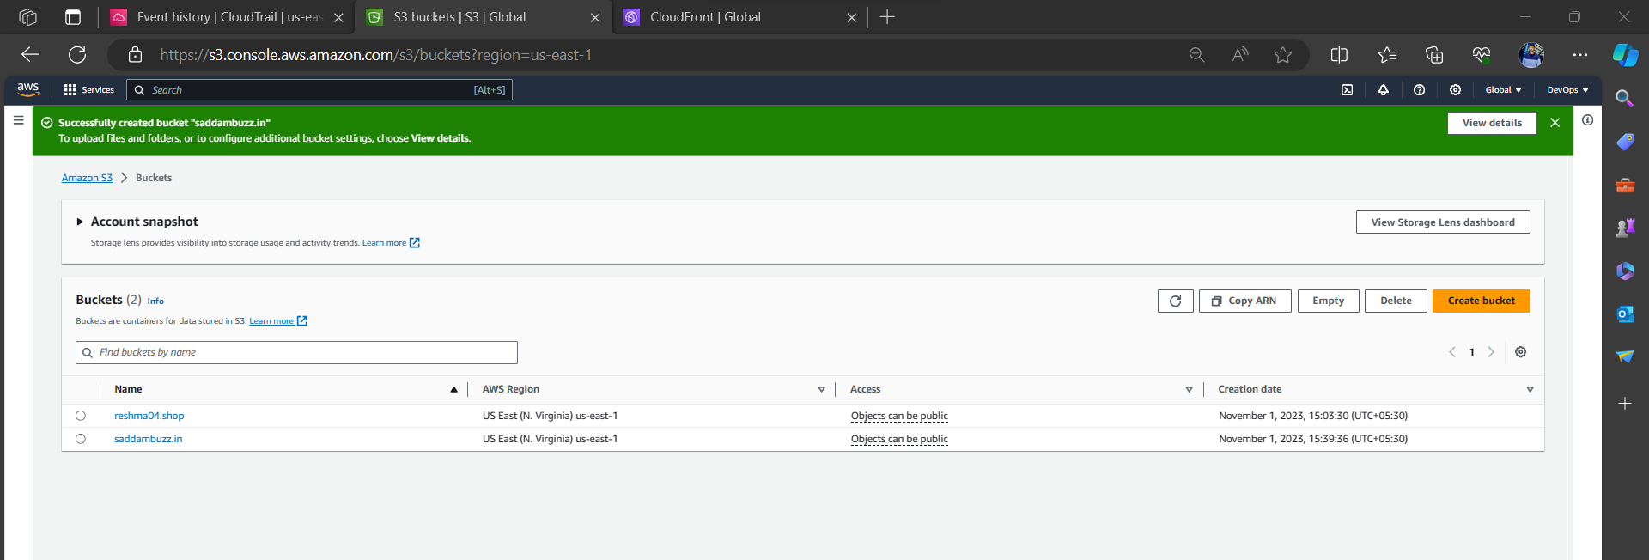

1. **Enable AWS CloudTrail:**
   * Navigate to the “AWS CloudTrail” service.
   * Click "Create trail."
   * Give your trail a name and optionally specify a destination S3 bucket. The bucket you created in step 2 is a good choice.
   * Under "Storage location," choose "Choose an existing S3 bucket."
   * In “Additional settings” Enable Log file validation, SNS notification delivery.

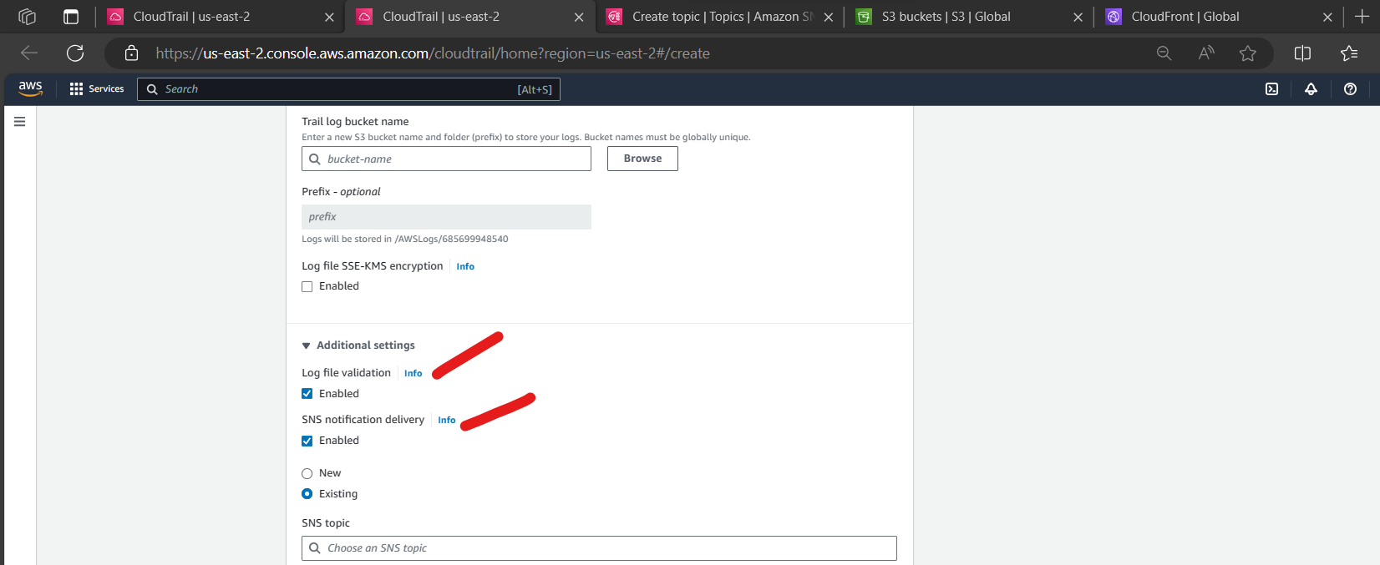

* + In “SNS topic” select existing, to attach existing SNS topic we need to create one Simple notification service.
  + Navigate to the “Simple notification service” service.
  + Click “Create topic” attached reference screenshot below.

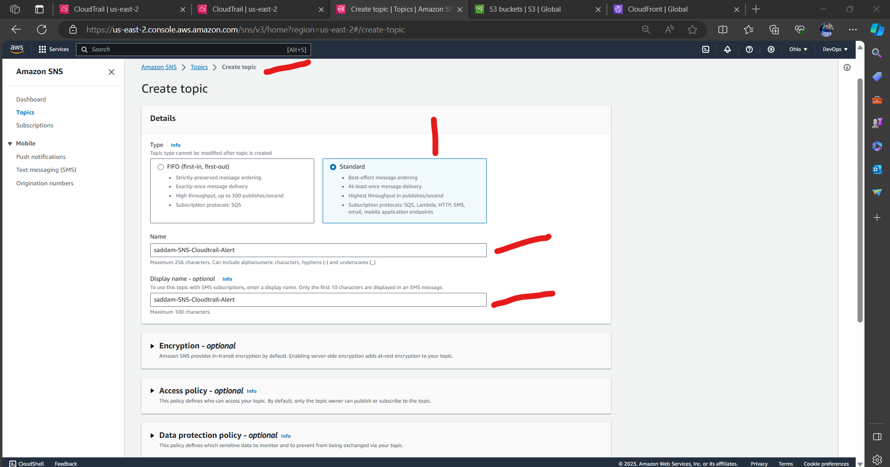

* + We created “SNS Topic” successfully.

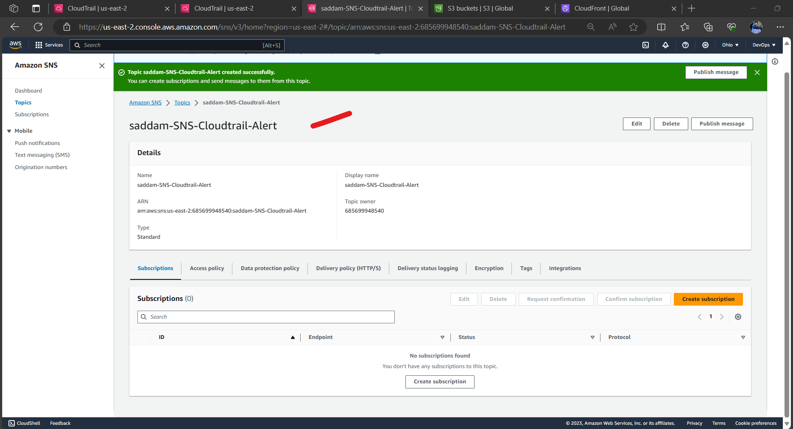

* + To this topic what kind of alert ⚠ We need to configure.
  + Click on Create Subscription. Attached reference screenshot below.

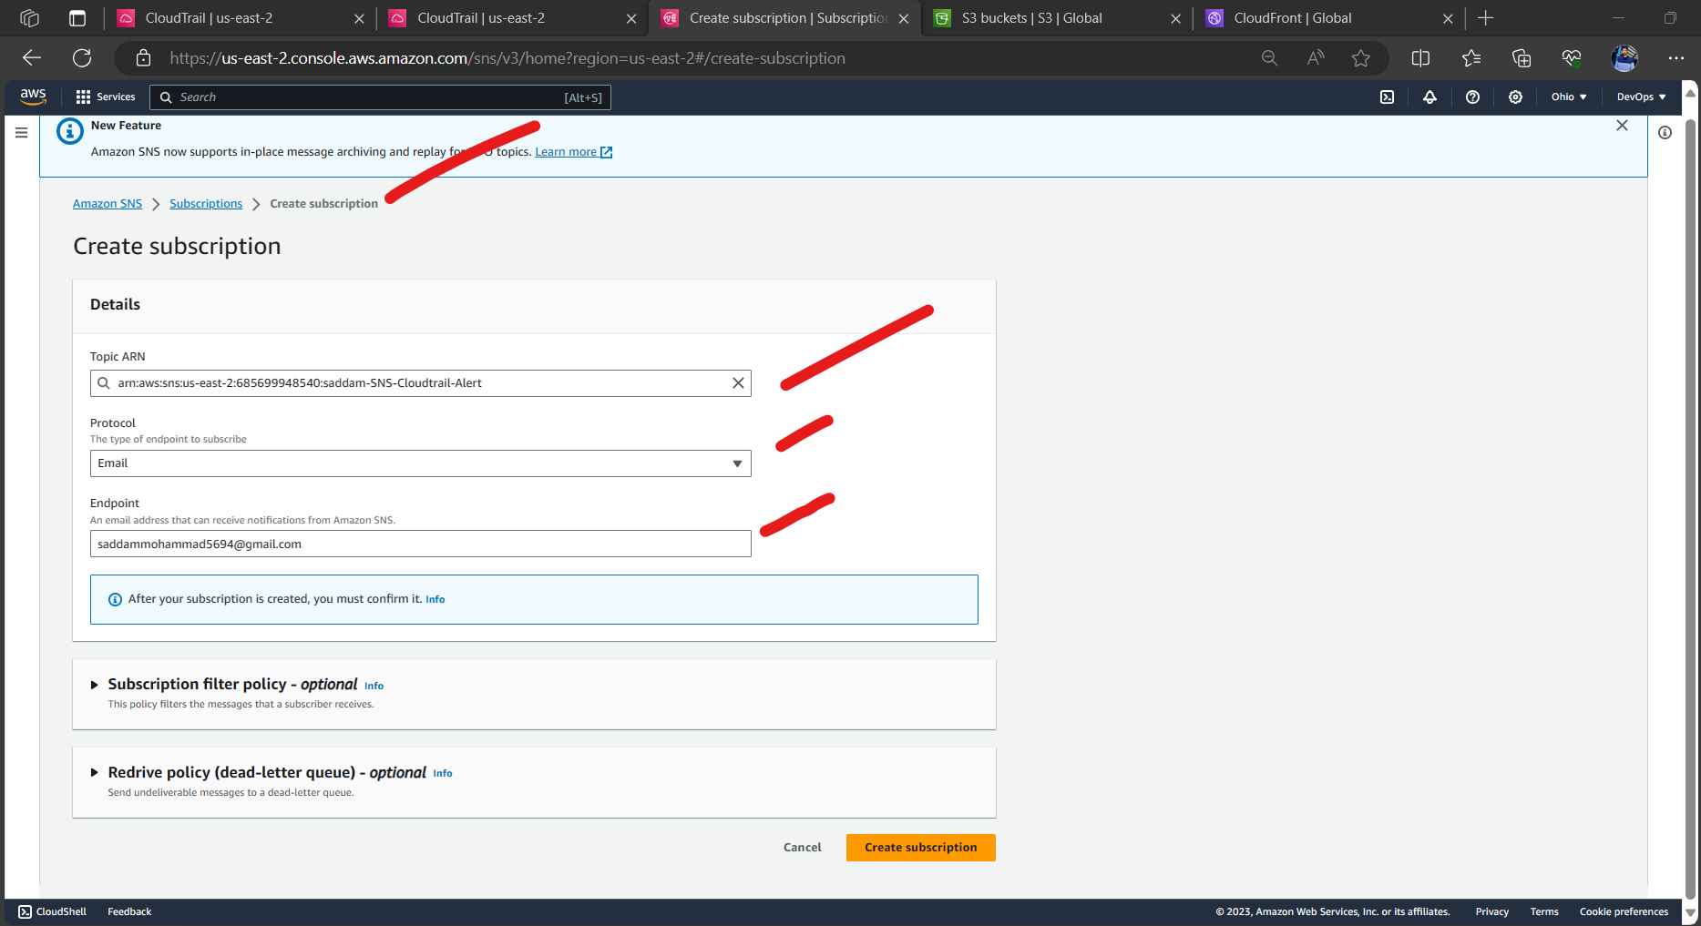 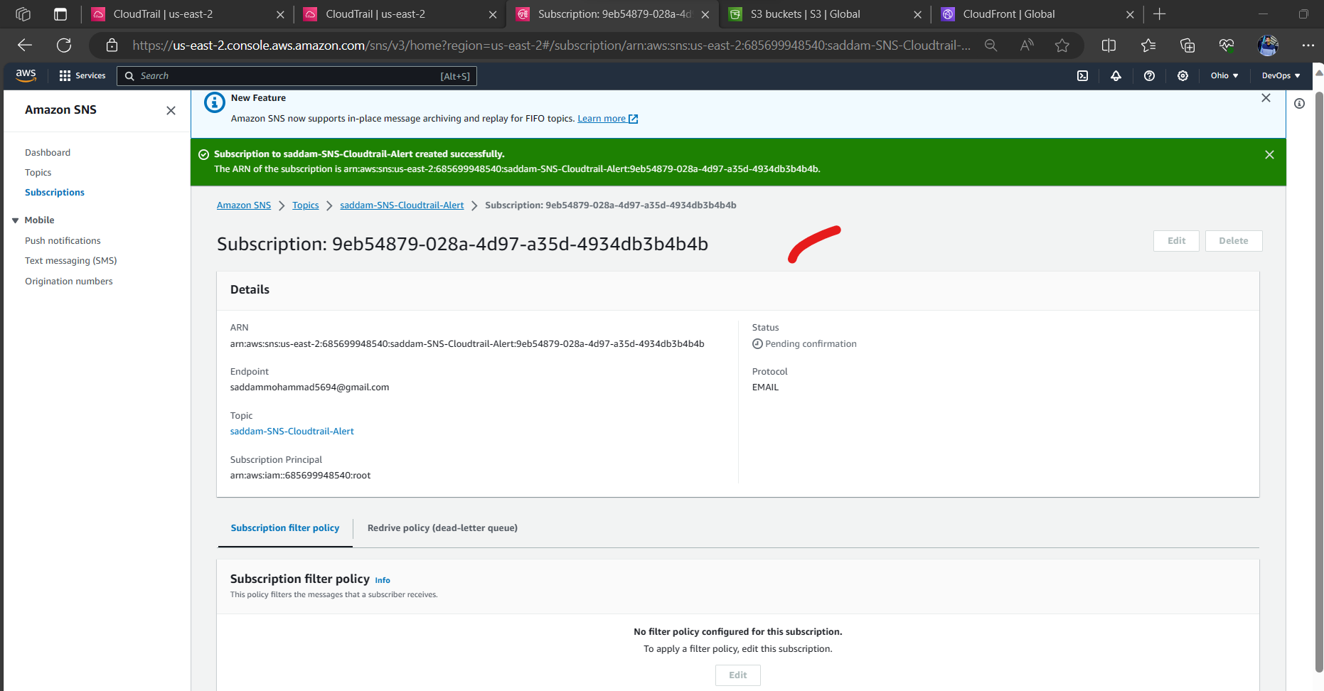

* + Login to your Gmail account and confirm.

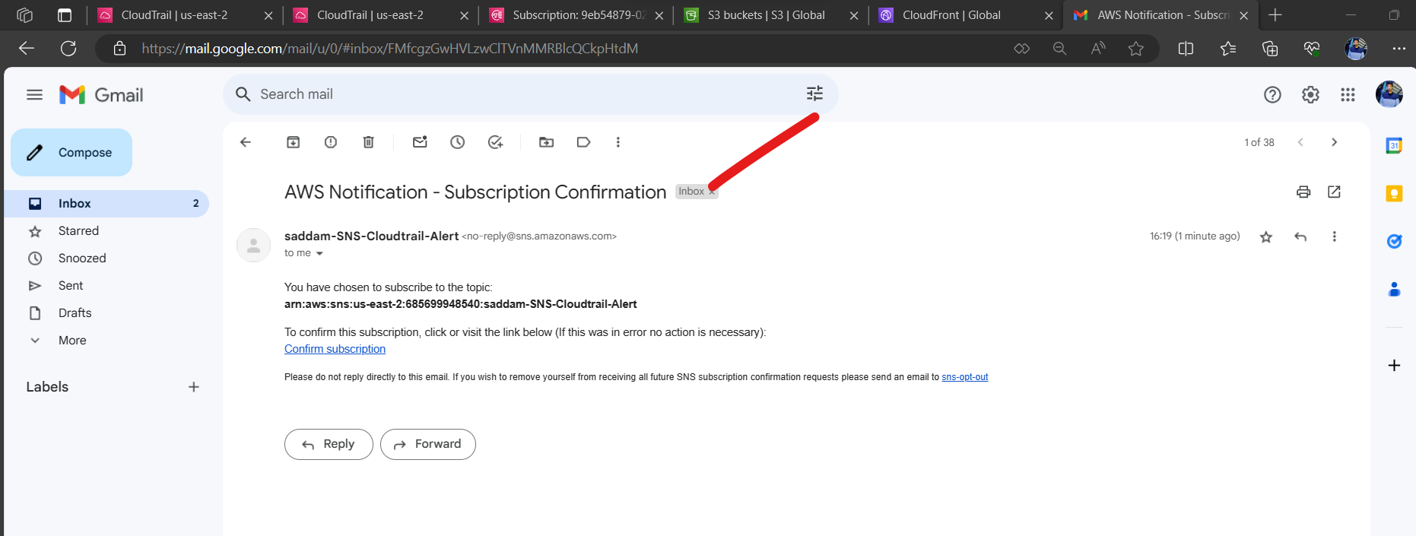

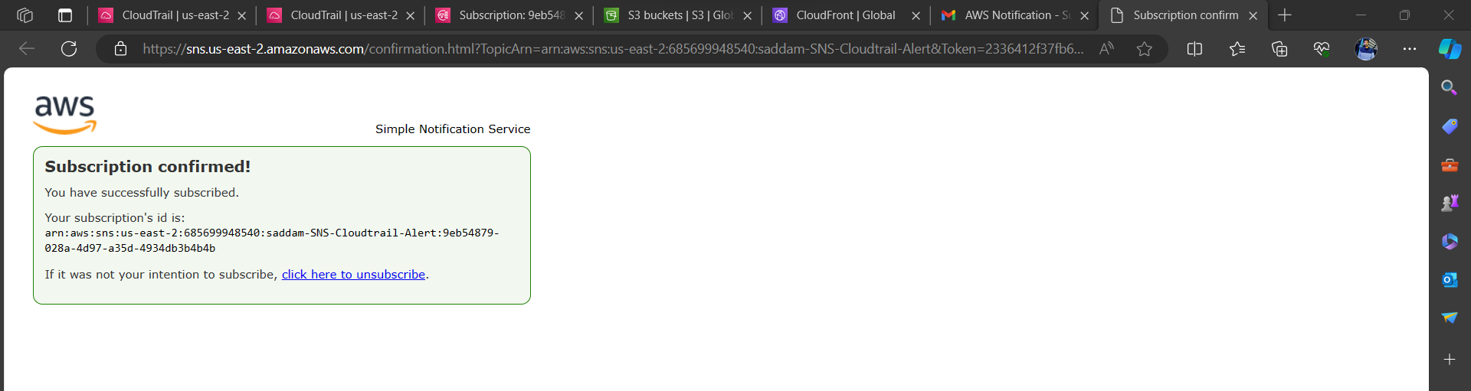 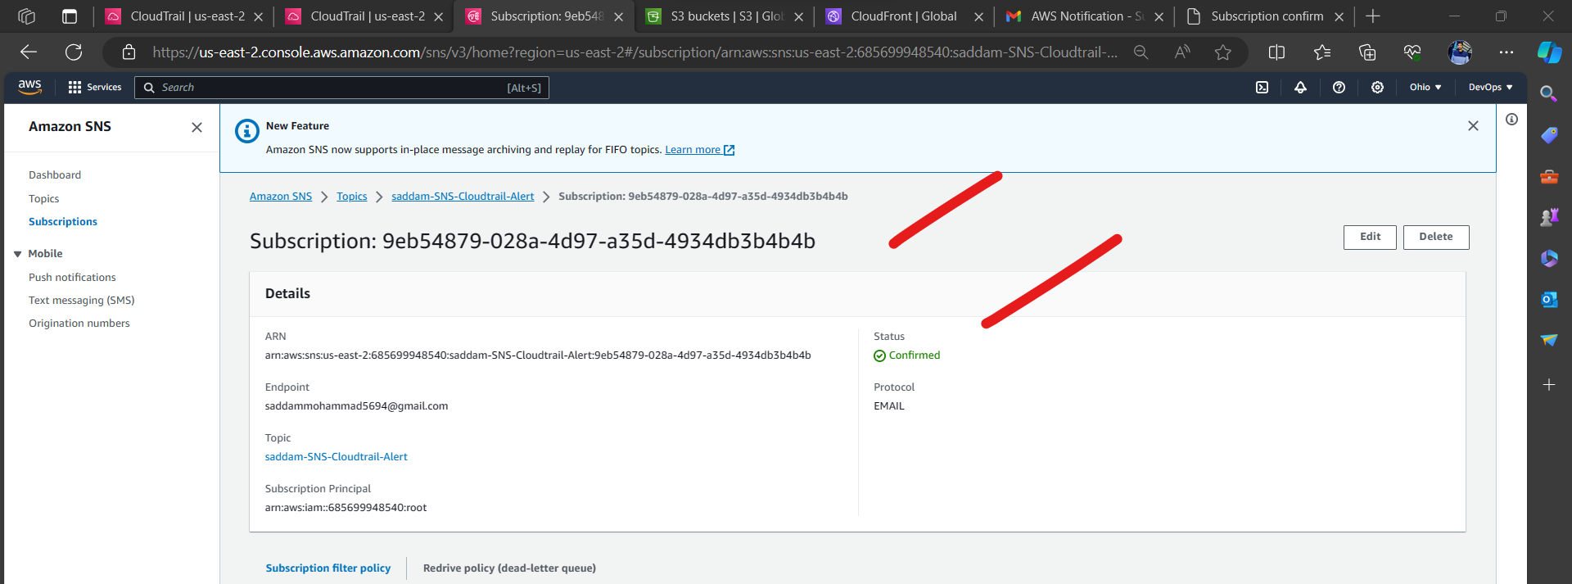

1. **Add CloudWatch Logs:** To send CloudTrail logs to CloudWatch Logs for real-time monitoring and alerting, follow these steps:
   * In the CloudTrail console, select new.

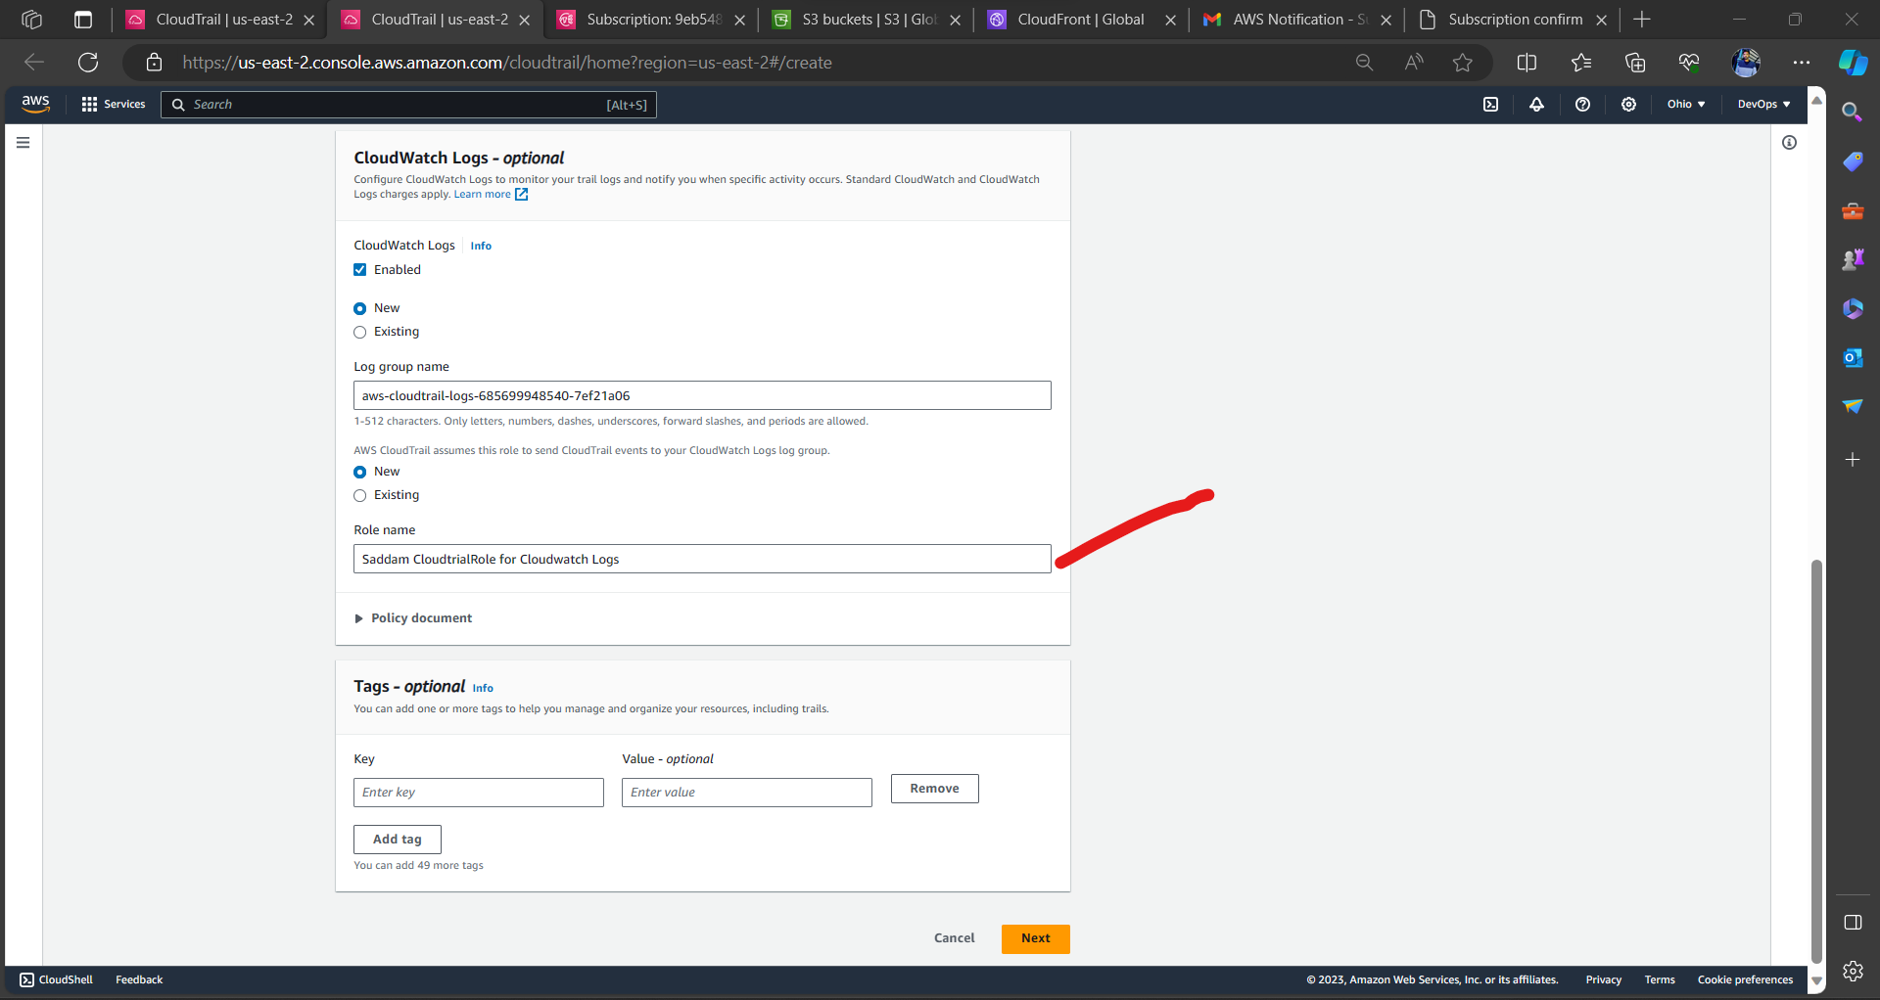

* + In “Choose log events” attached reference screenshot below.

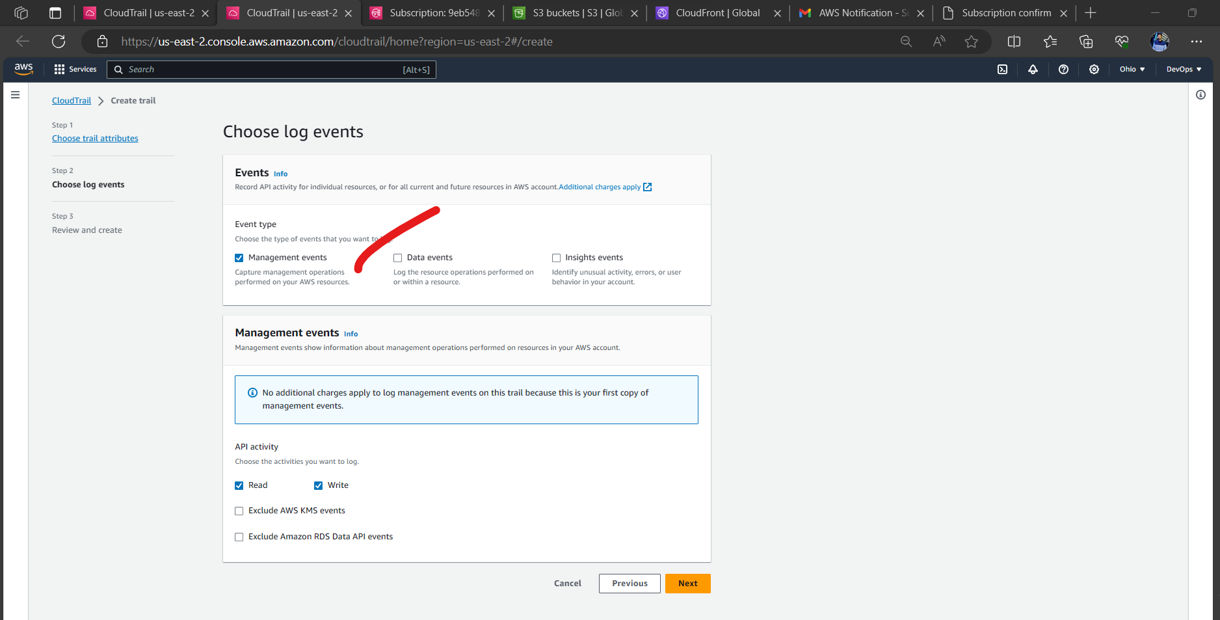

* + Note; - we can also select Date events, Insight events as per our requirement.

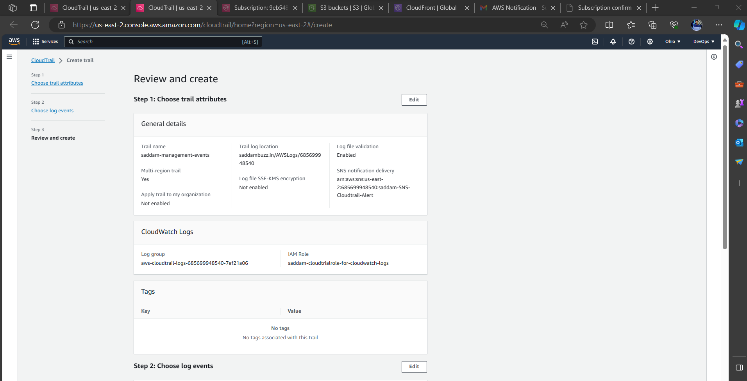 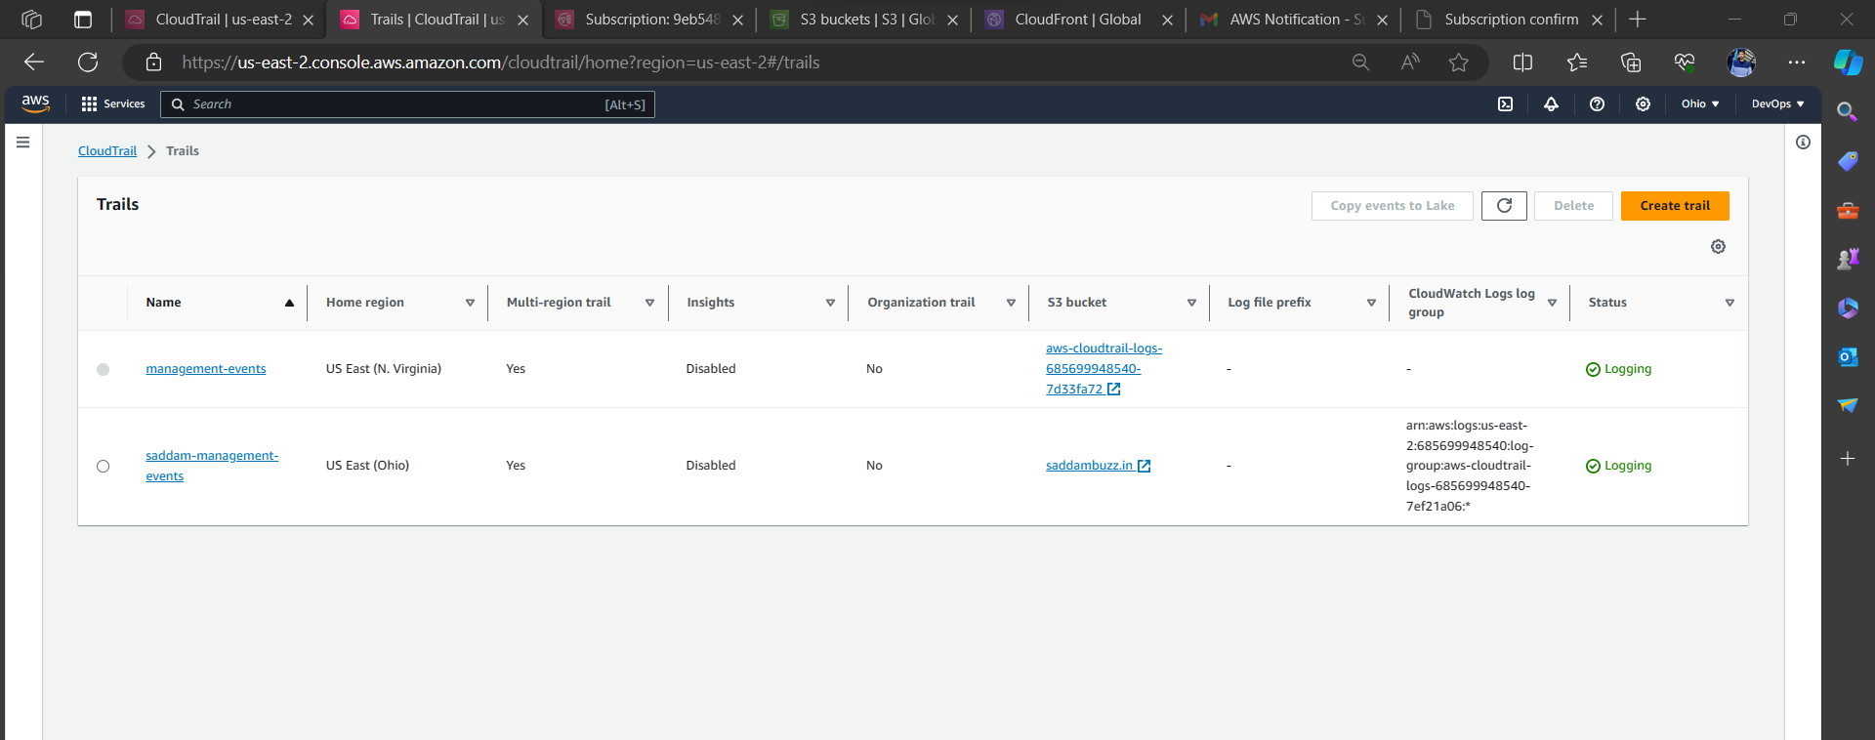

* + Navigate to S3 bucket and validate Cloud Trial Logs.

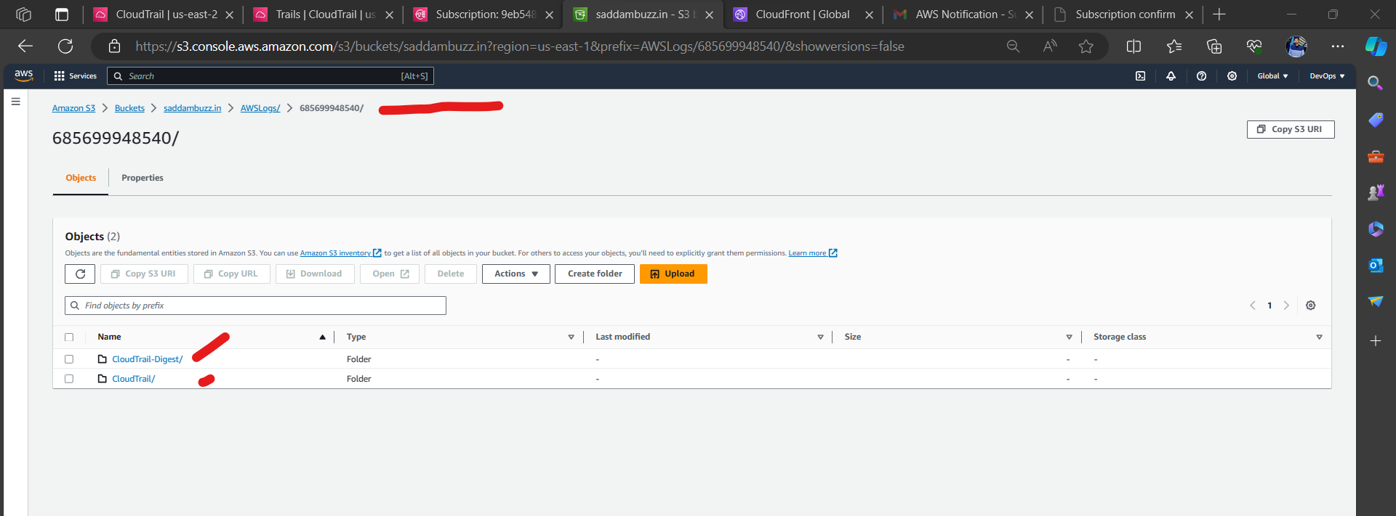

* + I have Created one EC2 Instance in US east -1 validating that Logs in S3.

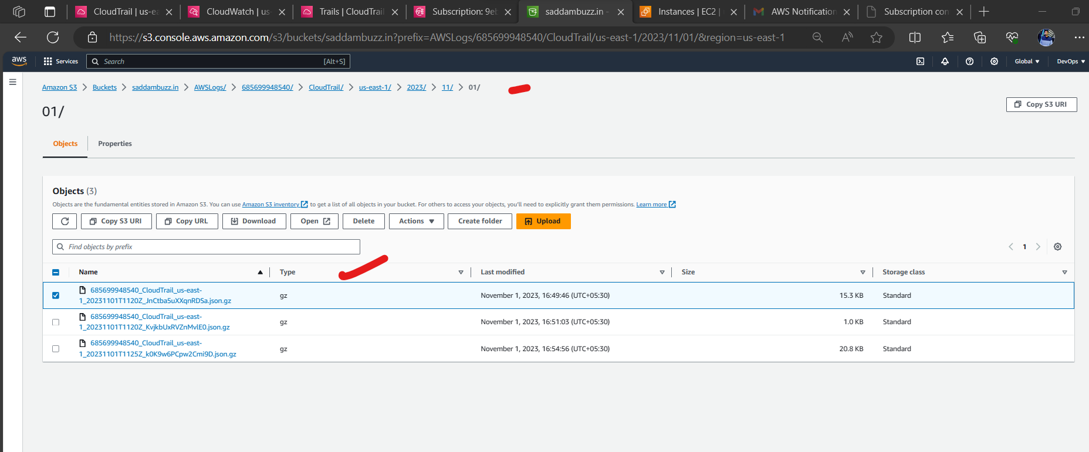 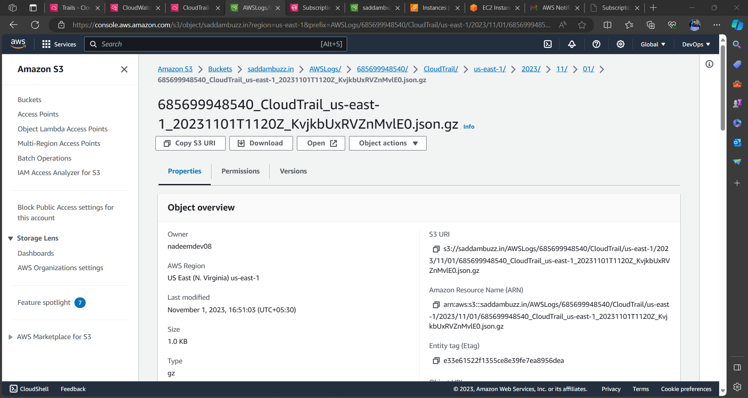

* + In the "CloudWatch Logs" validate the Logs.

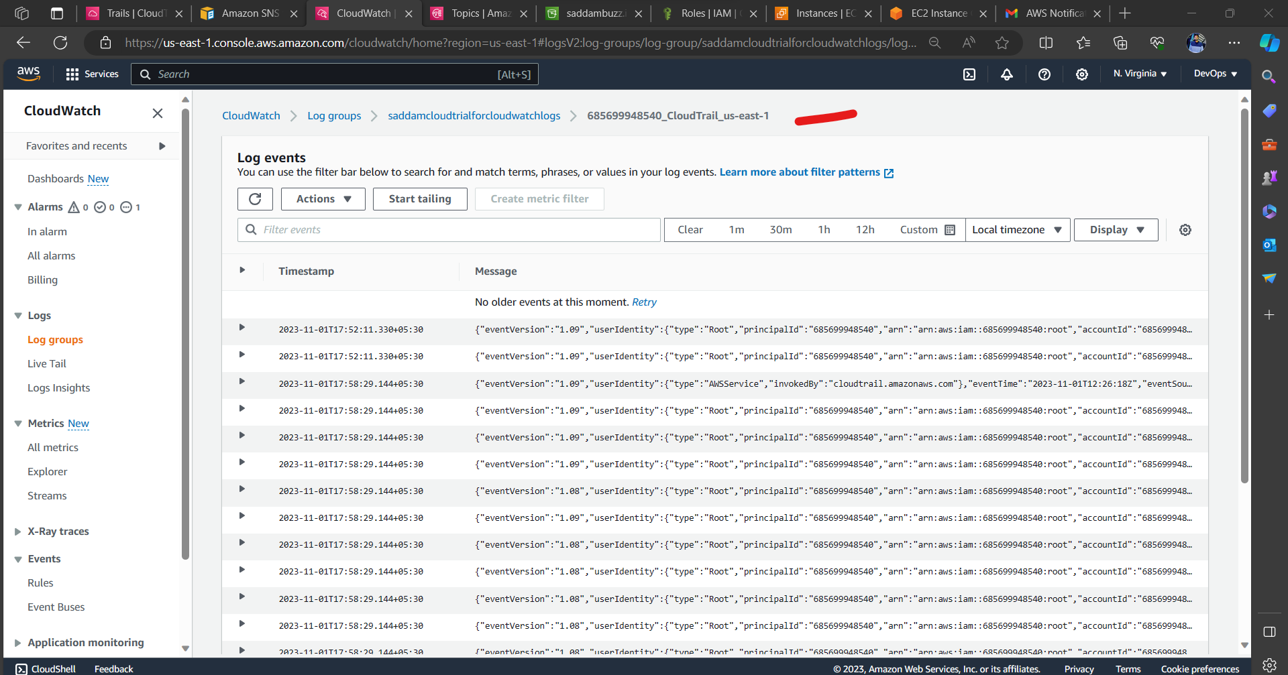

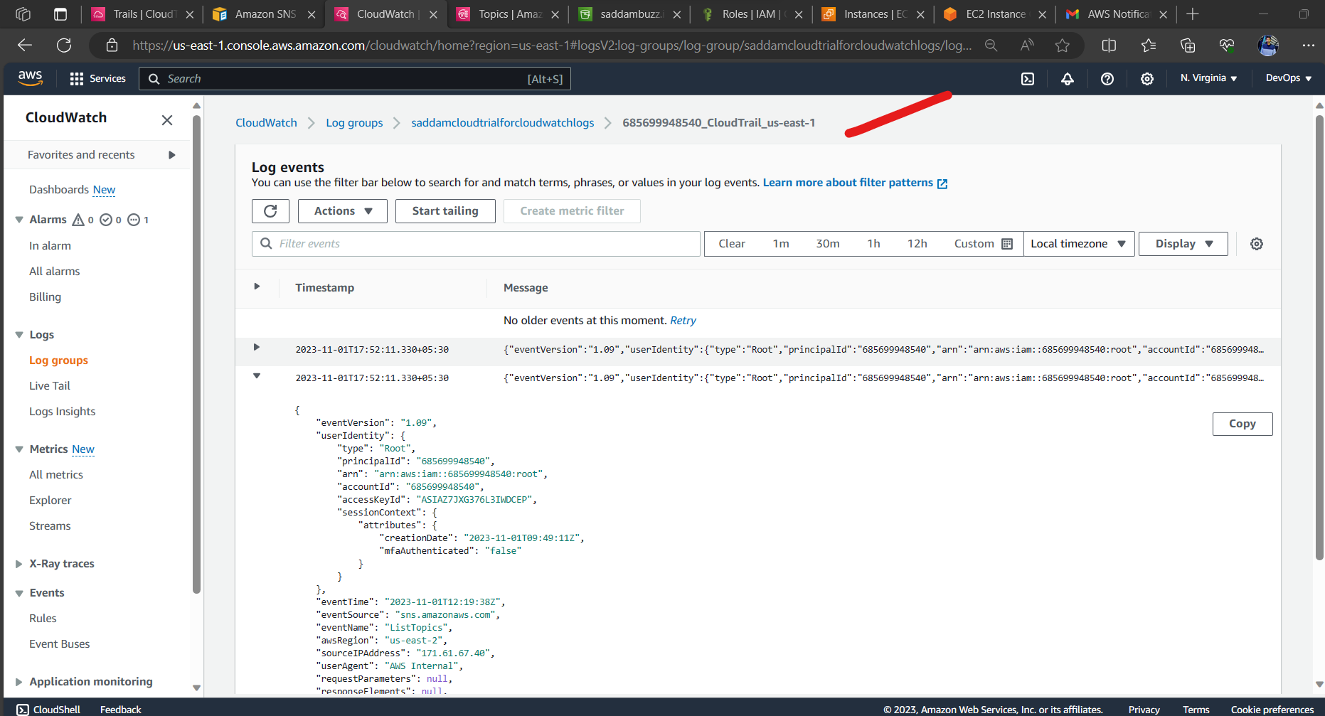

# **2) Enable SNS for CloudTrail to send alert on email.**

1. **Create an SNS Topic:**
   * Log in to the AWS Management Console.
   * Navigate to the SNS service.
   * Click "Create Topic."
   * Give your topic a name and display name.
   * Add a description.
   * Click "Create Topic."

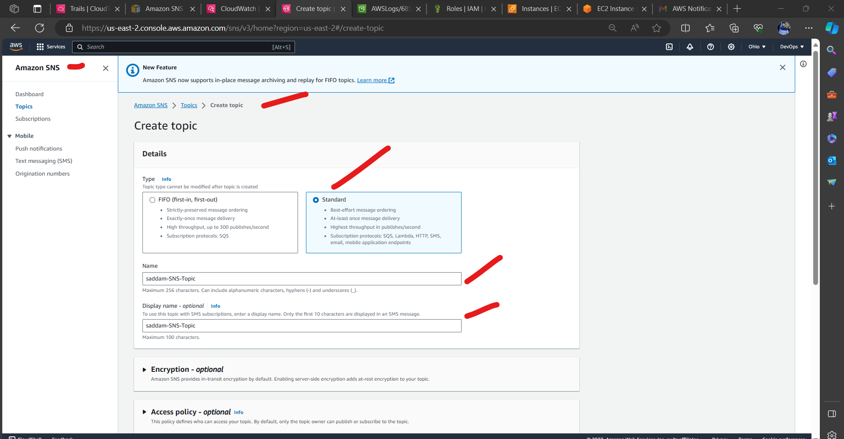

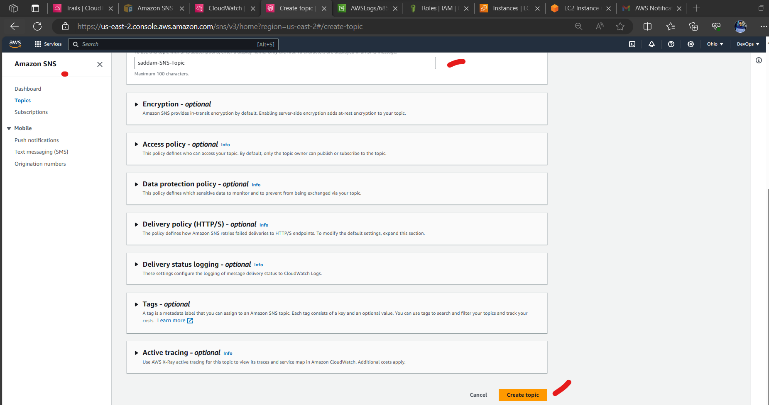

1. **Subscribe to the SNS Topic:**
   * Select the SNS topic which we created.
   * Click the "Create Subscription" button.
   * Choose the "Email" protocol.
   * Enter the email address where we want to receive CloudTrail alerts. saddammohammad@gmail.com
   * Click "Create Subscription."

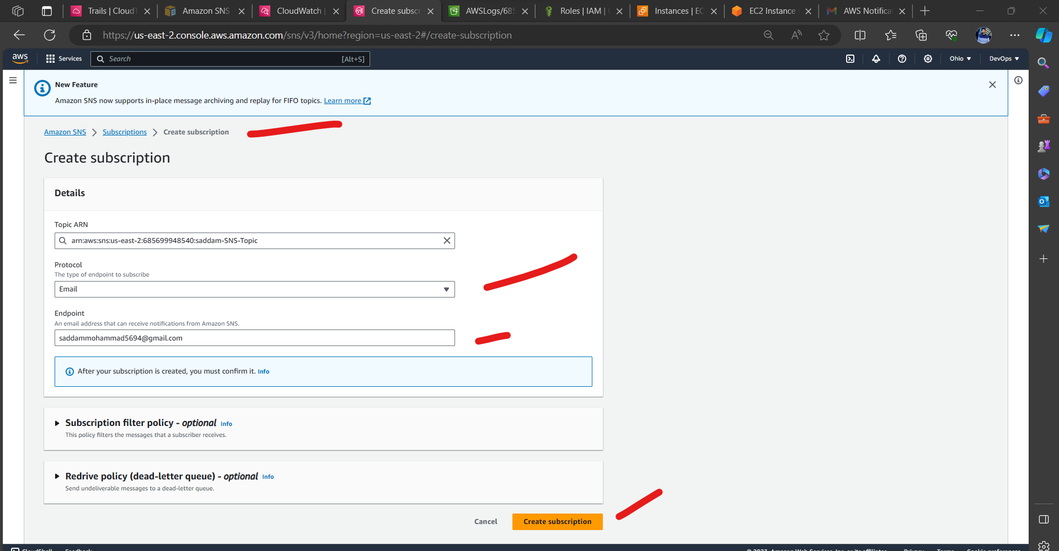

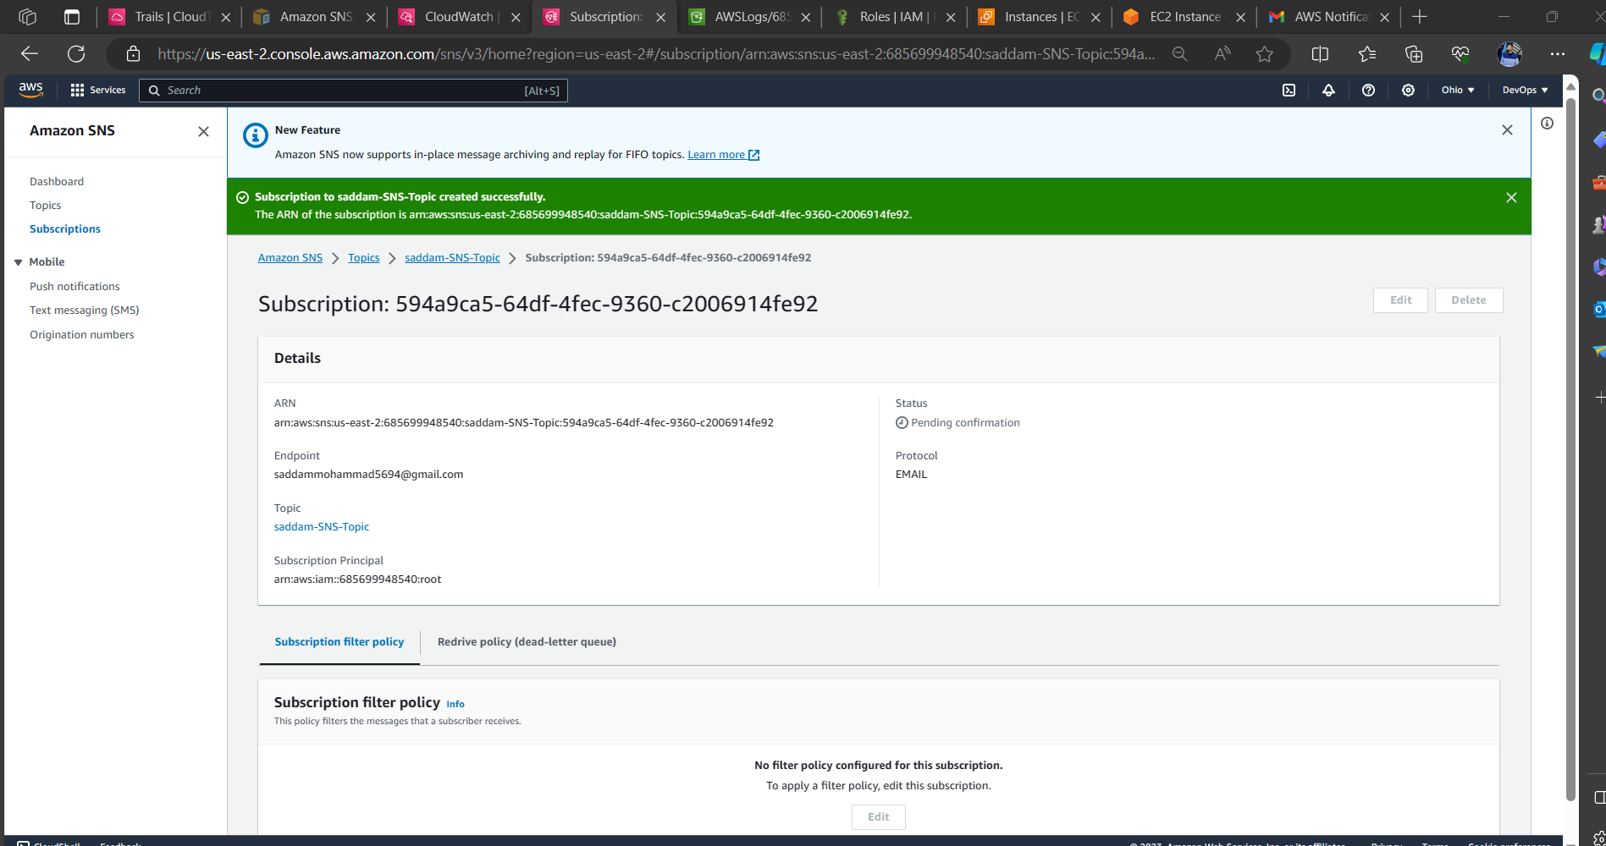

1. **Confirm Email Subscription:**
   * Check in email inbox for a confirmation message from AWS SNS.
   * Click the confirmation link in the email to verify the subscription.

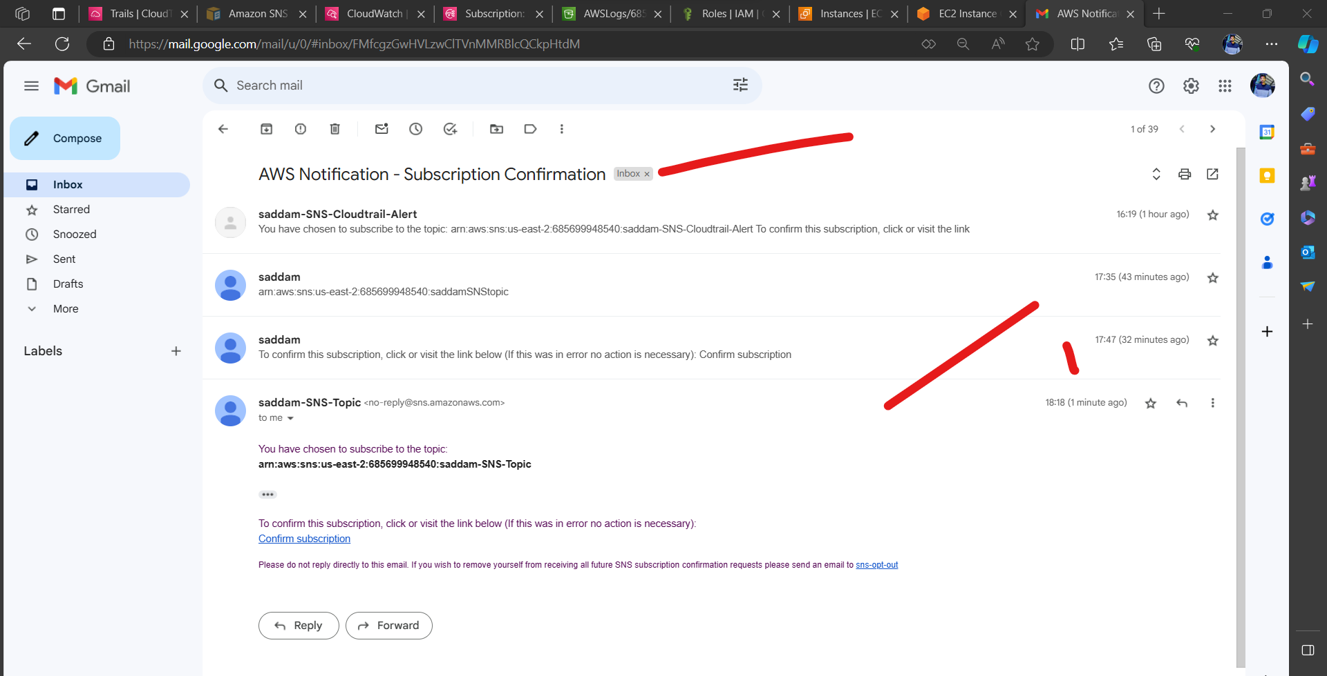 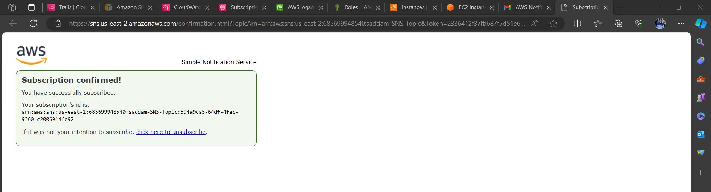

# **3) Configure cloud watch monitoring and record the CPU utilization and other metrics of ec2.**

1. **Log in to the AWS Management Console**
2. **Launch an Amazon EC2 Instance**

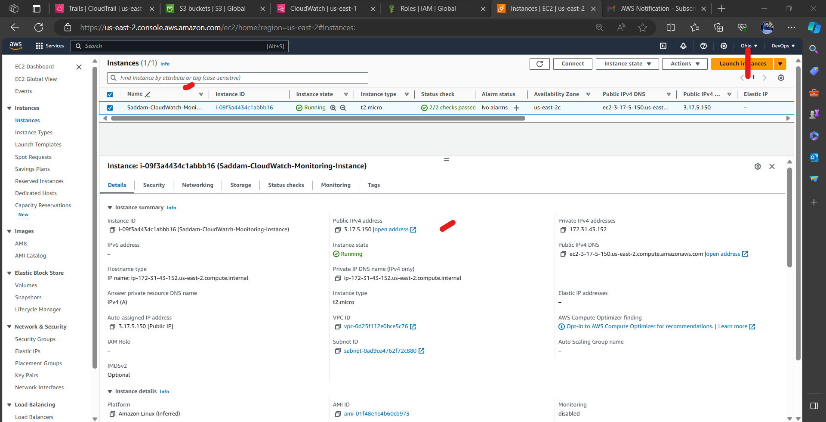 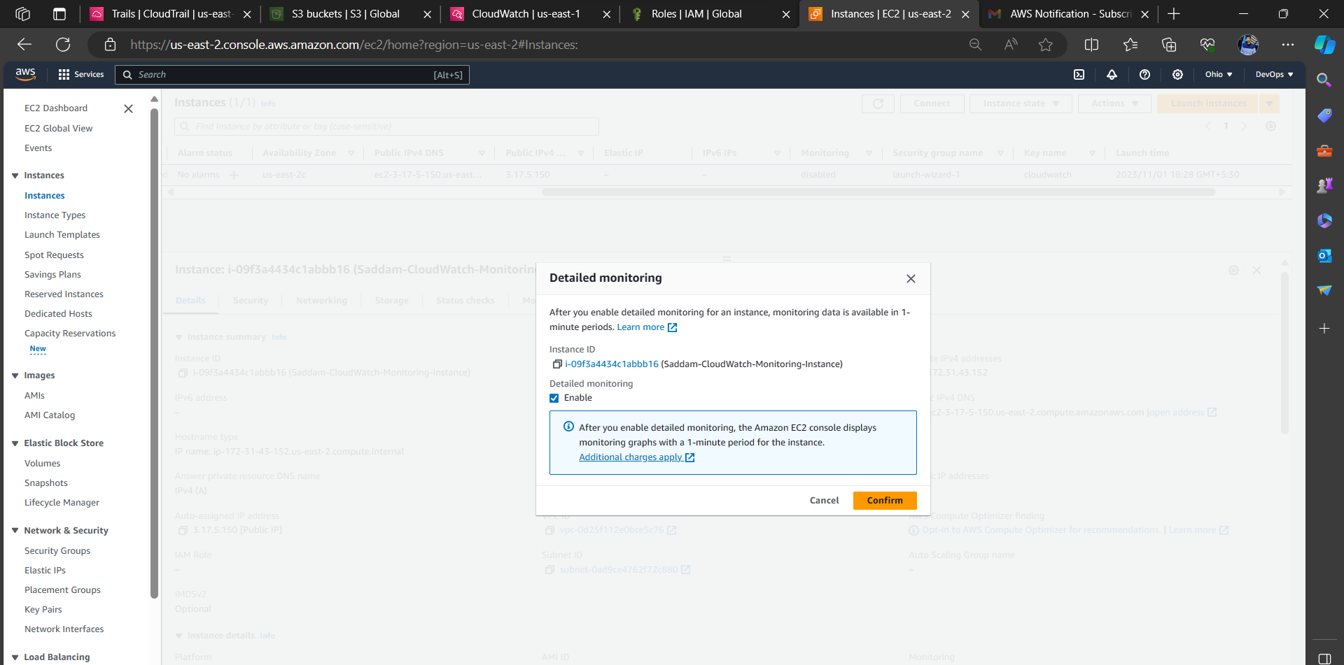

1. **Access the Ec2 Instance**

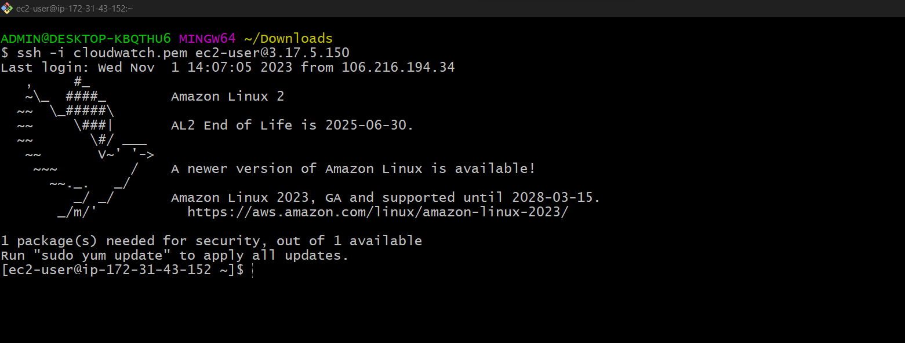

1. Customize CPU Utilization to 1 minute.

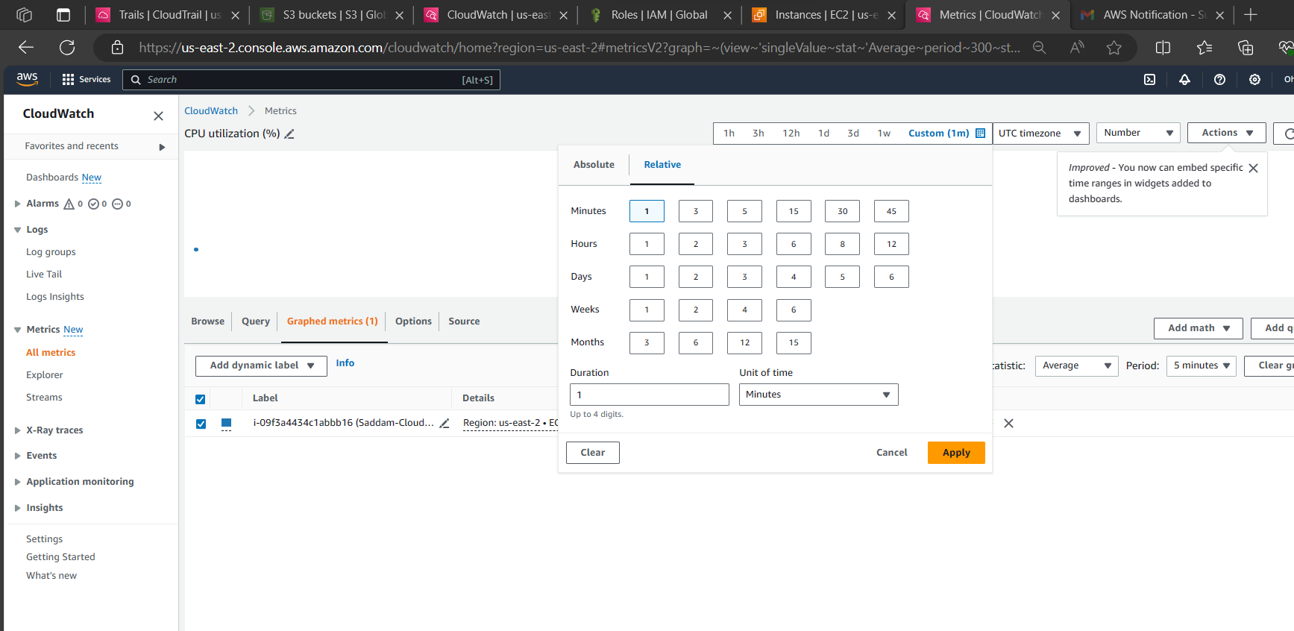

1. Add fake stress on CPU run following command.  
   yes > /dev/null &

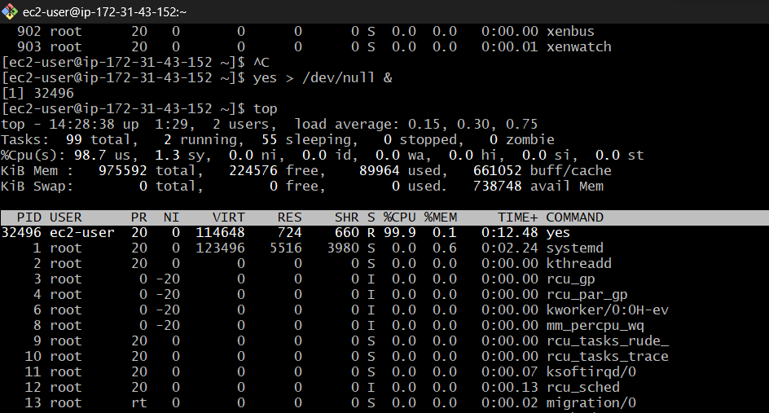

1. Create Custom Dashboards as per requirement.  
   Navigate to the CloudWatch service > click on Dashboards > click on create Dashboards

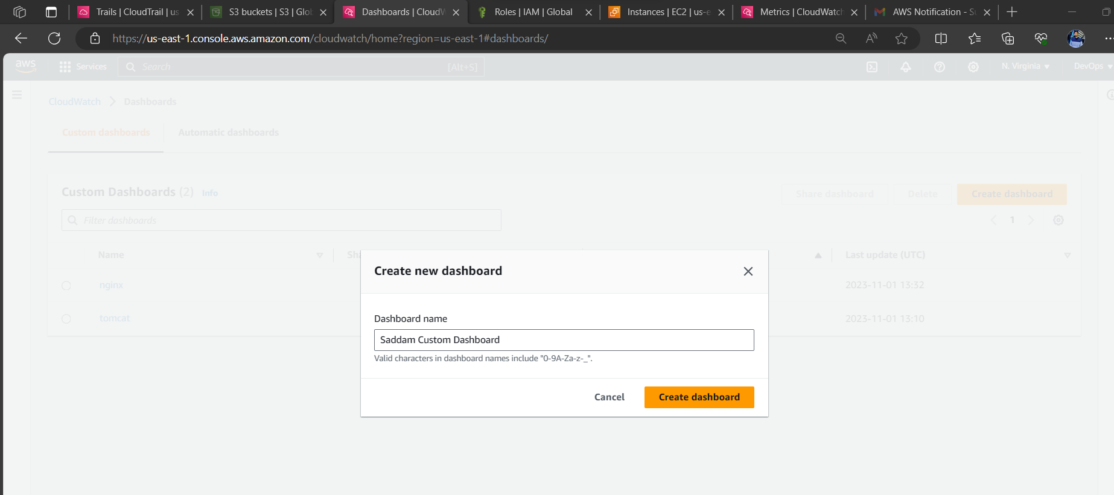

1. **Create a Custom Dashboard:**

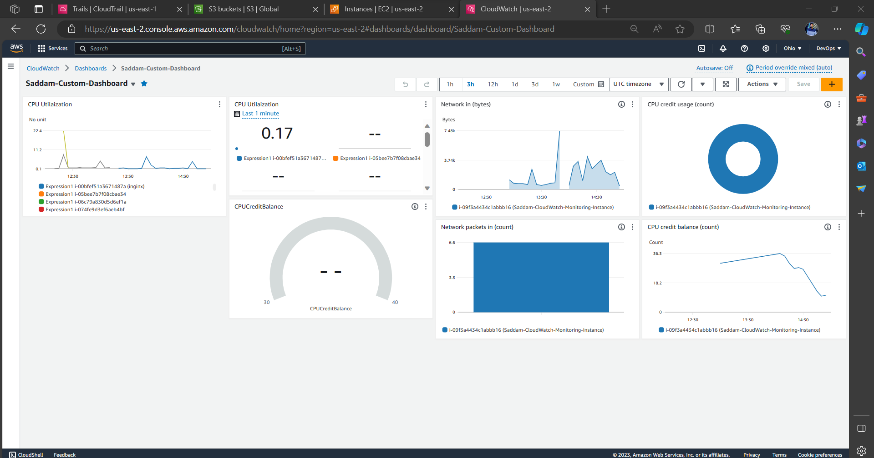

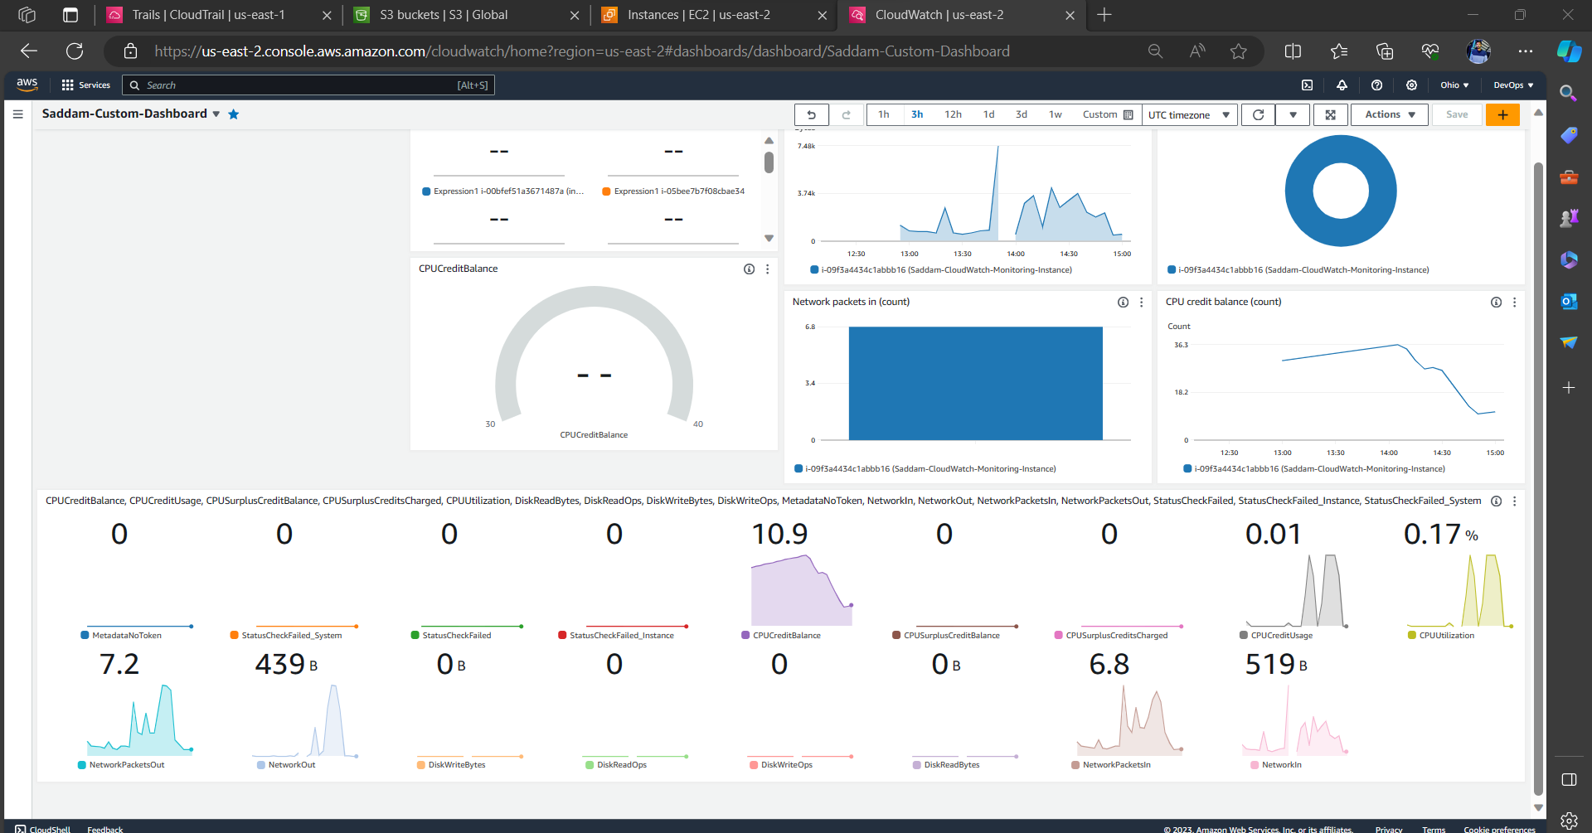

# **4) Create one alarm to send alert to email if the CPU utilization is more than 70 percent.**

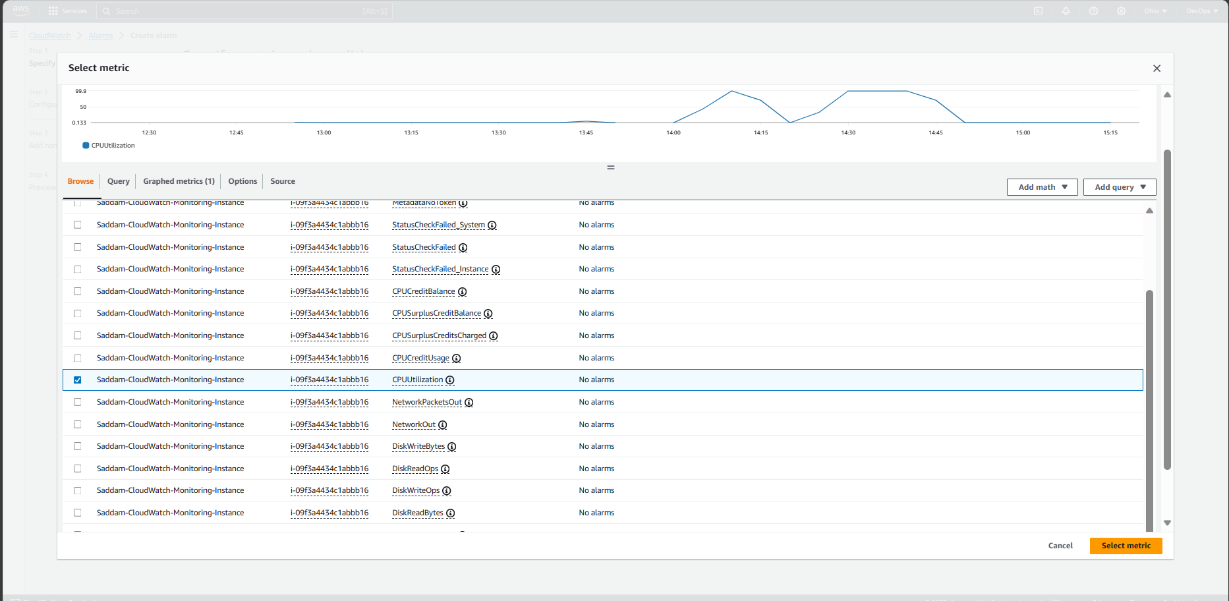

**Specify metric and conditions:** 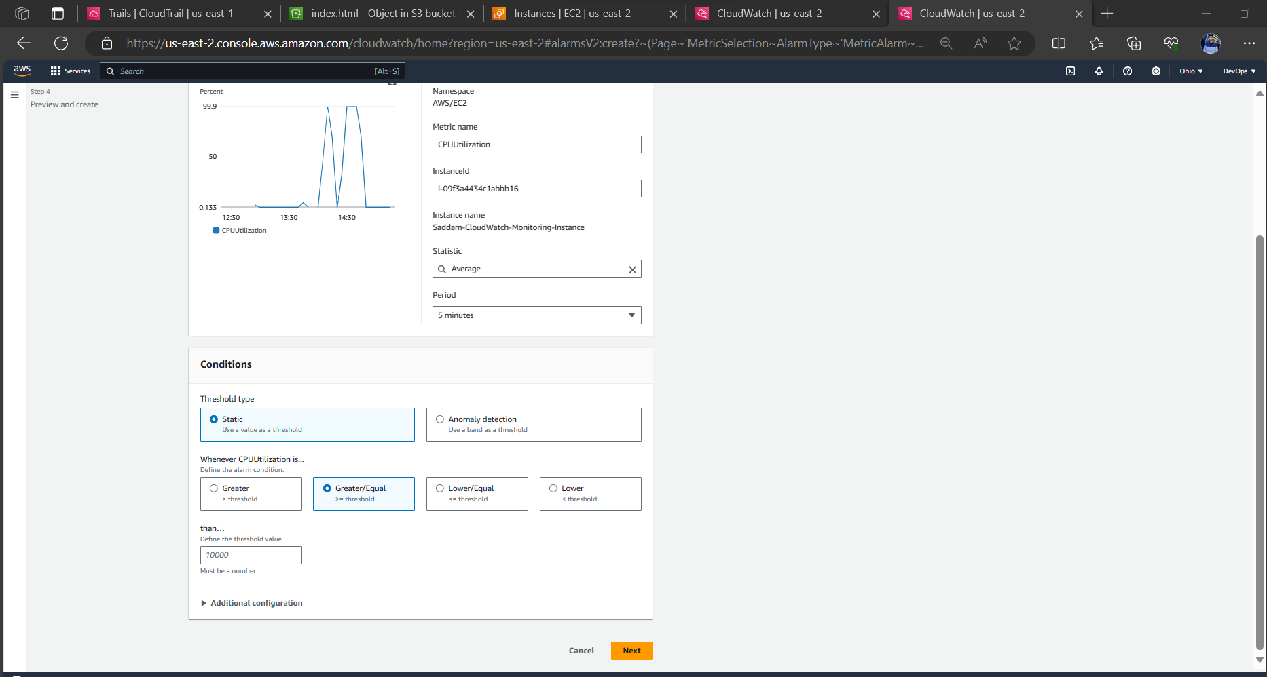

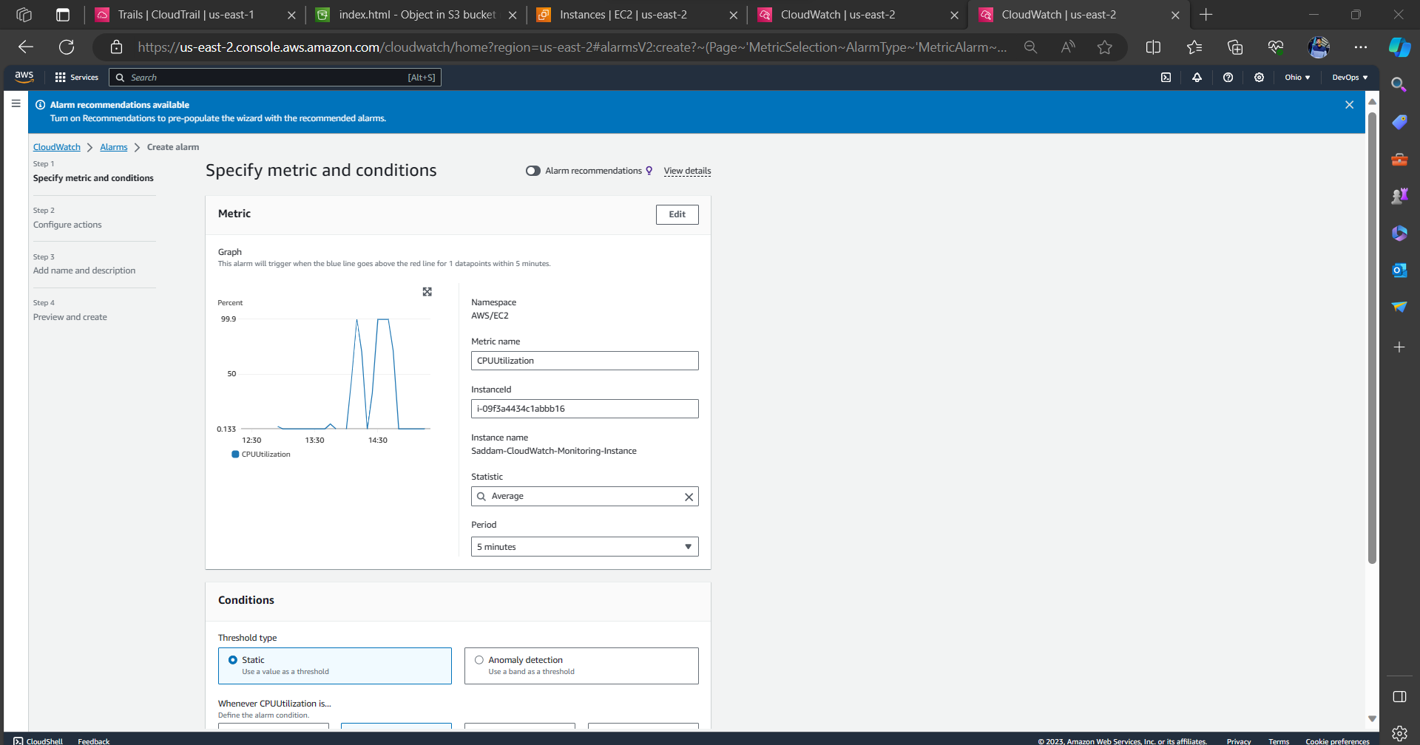

**Configure actions:**

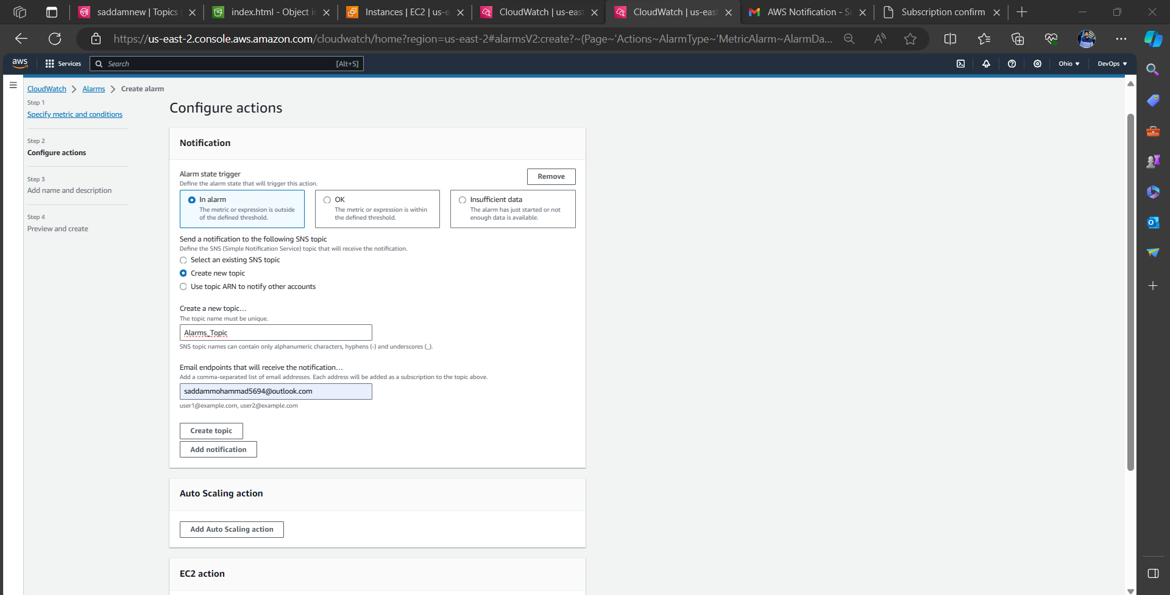

Add name and description:

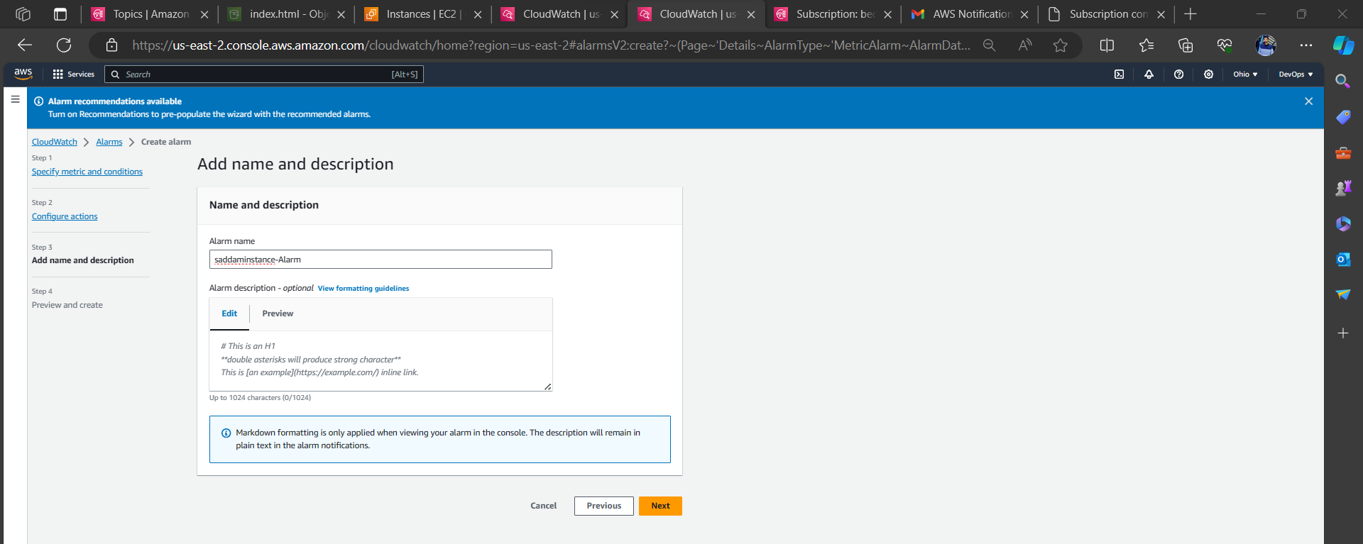

Preview and create:

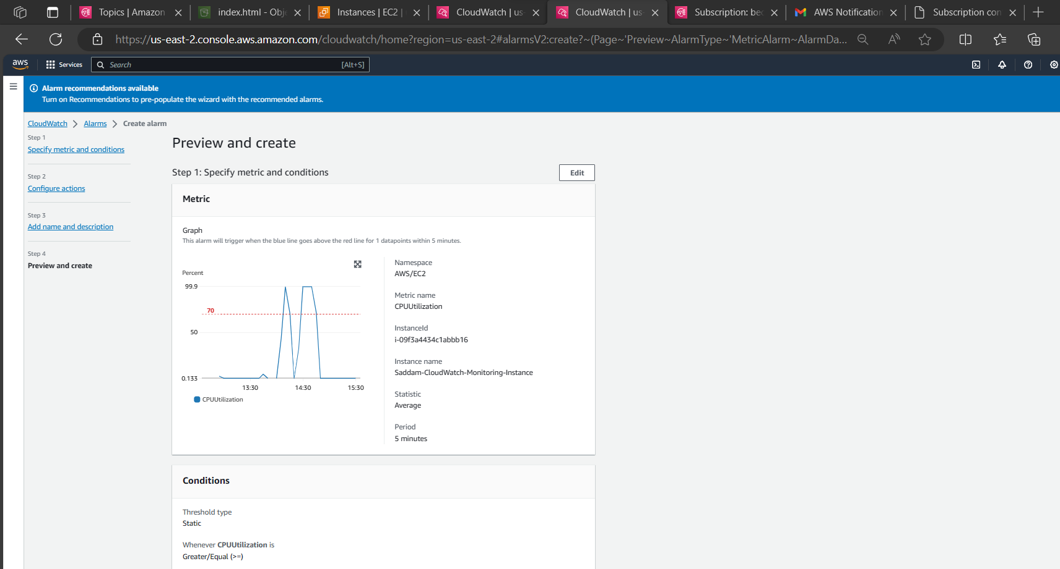 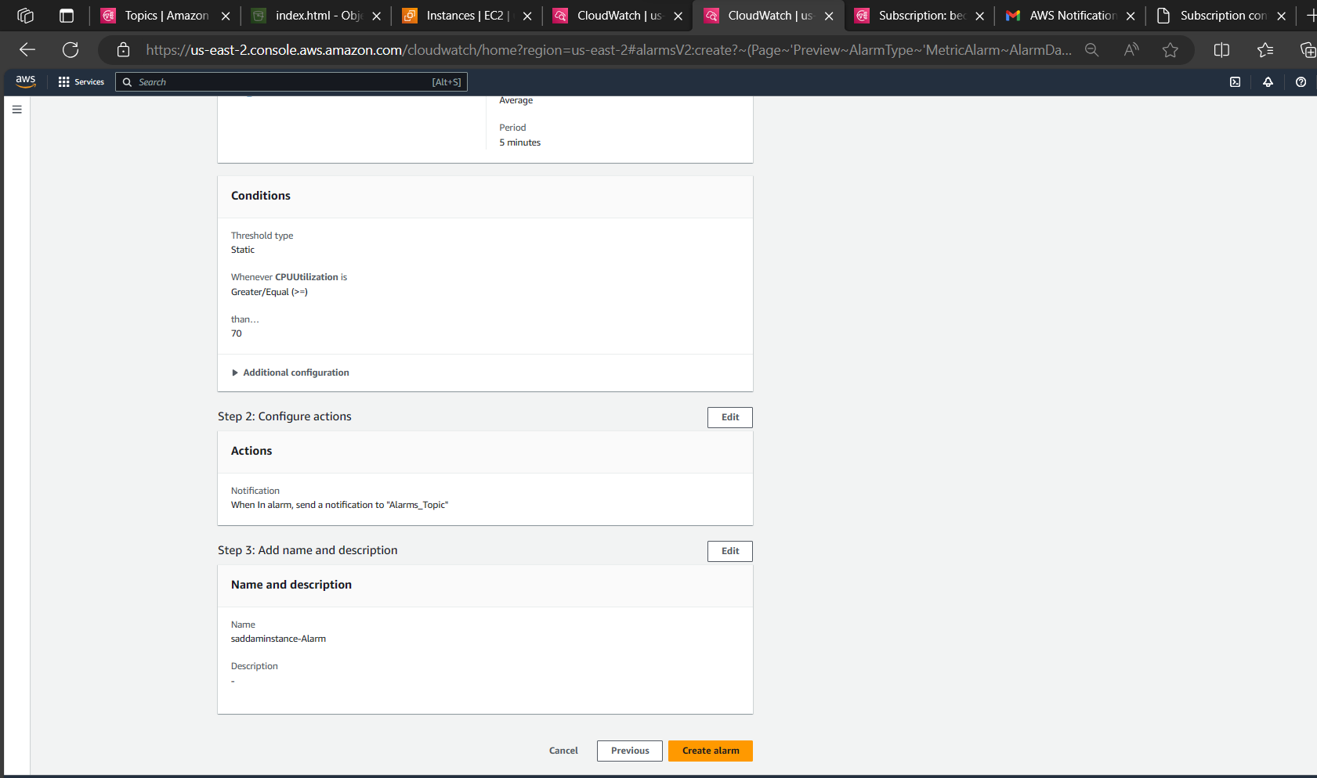 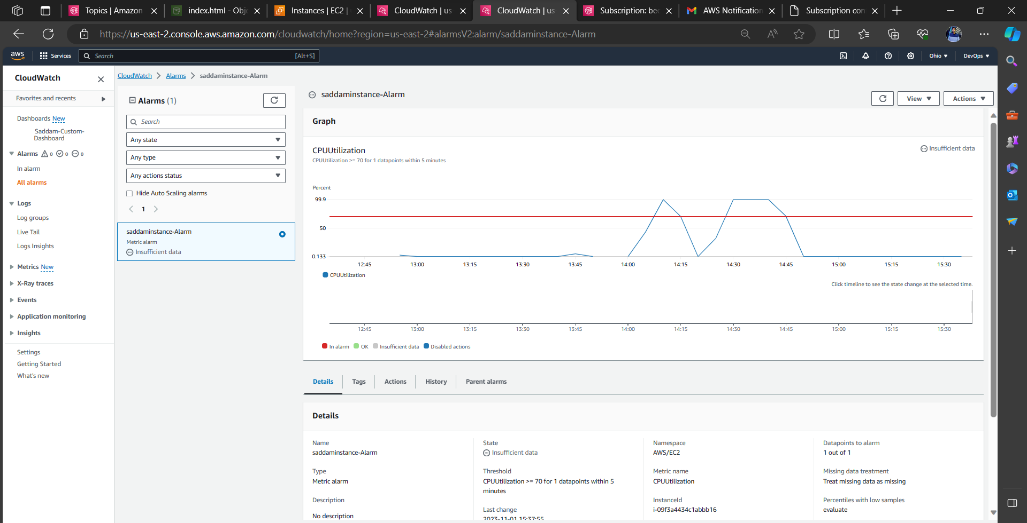

Result:   
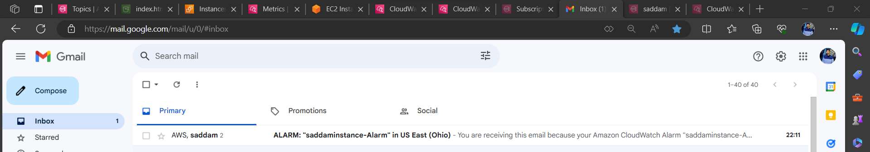

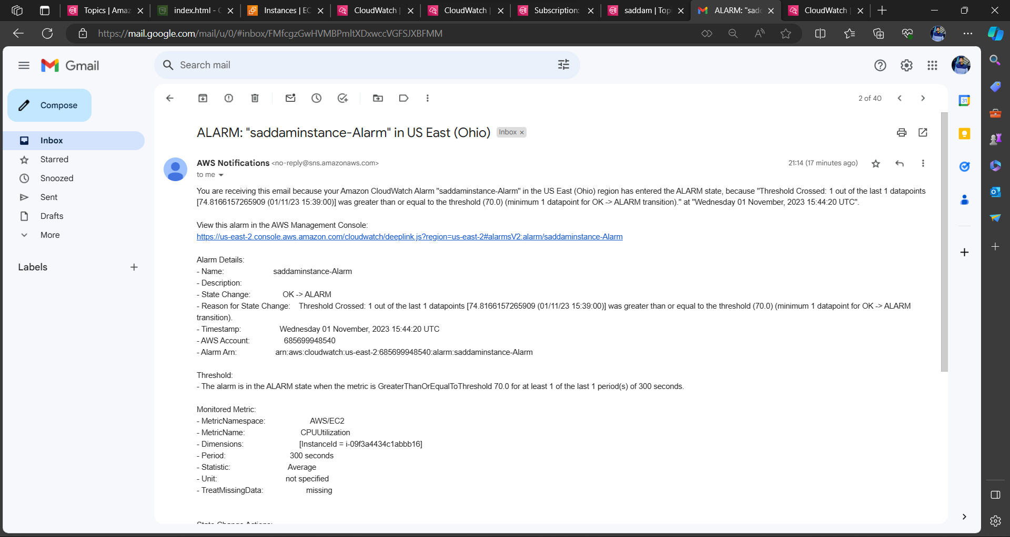

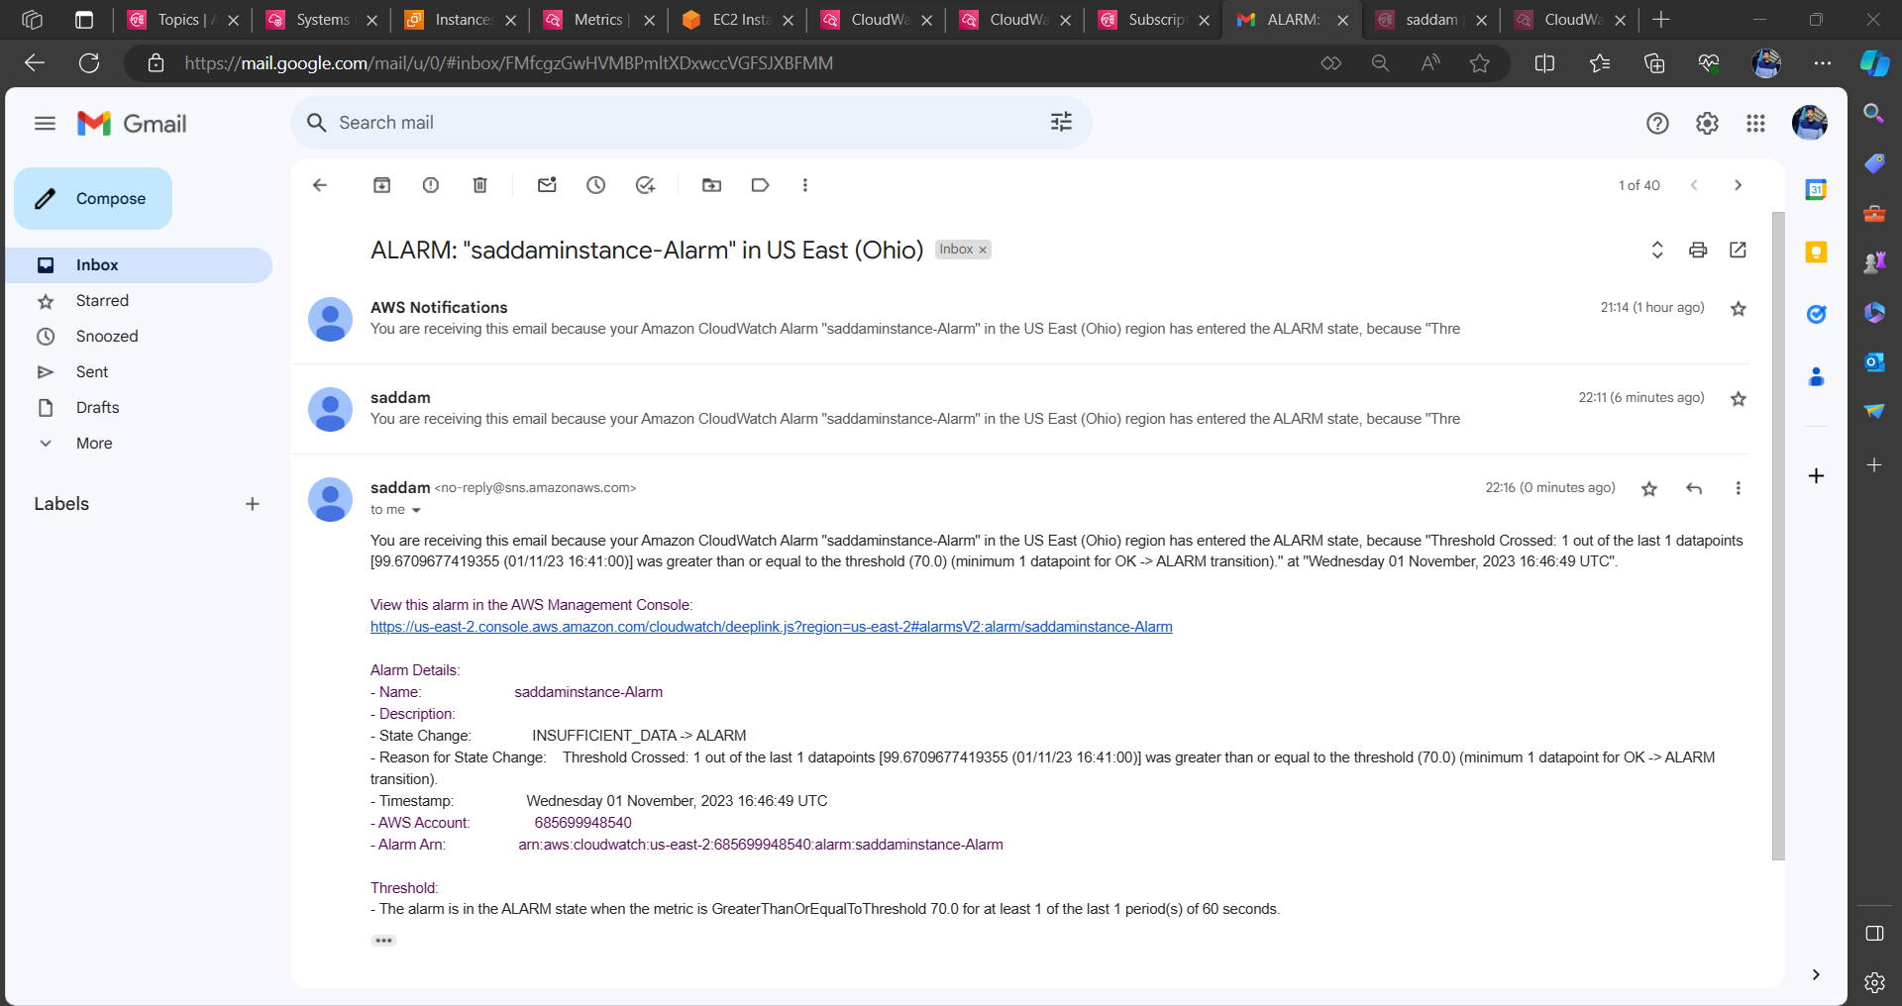

# **5) Create Dashboard and monitor tomcat service whether it is running or not and send the alert.**

Launch one instance.  
install tomcat in EC2  
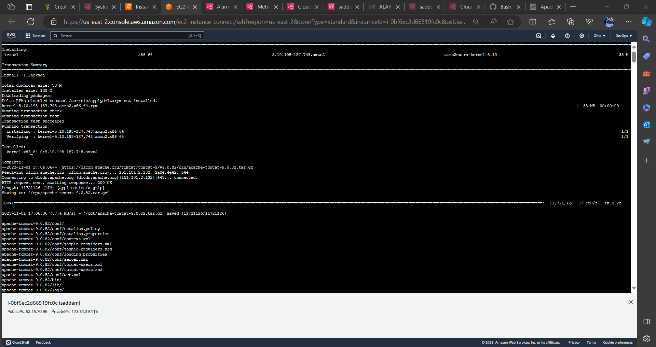  
start tomcat and add run the monitoring. bash script  
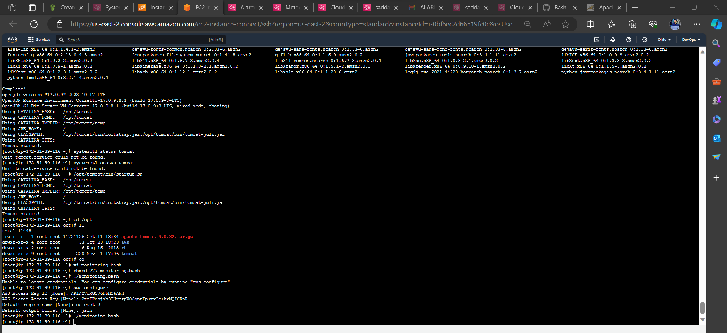  
after executing the bash script it will create one one metric in CloudWatch.  
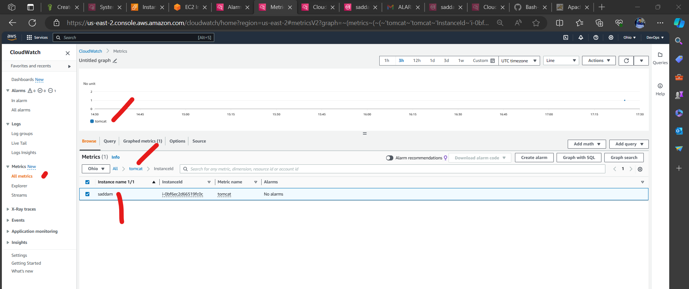  
create a custom dashboard to monitor tomcat.  
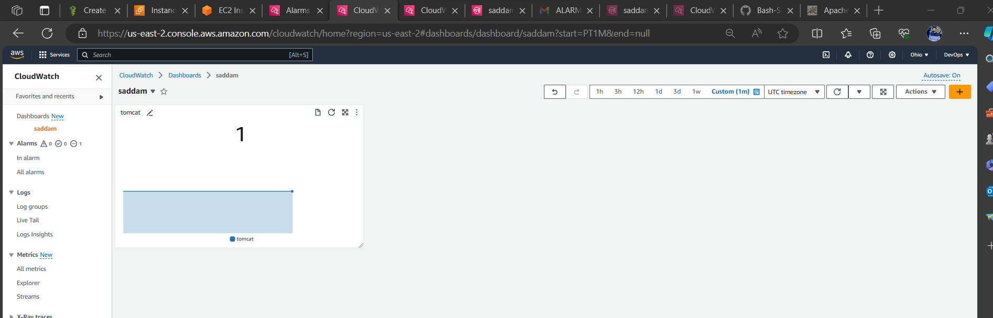  
Create Alarm  
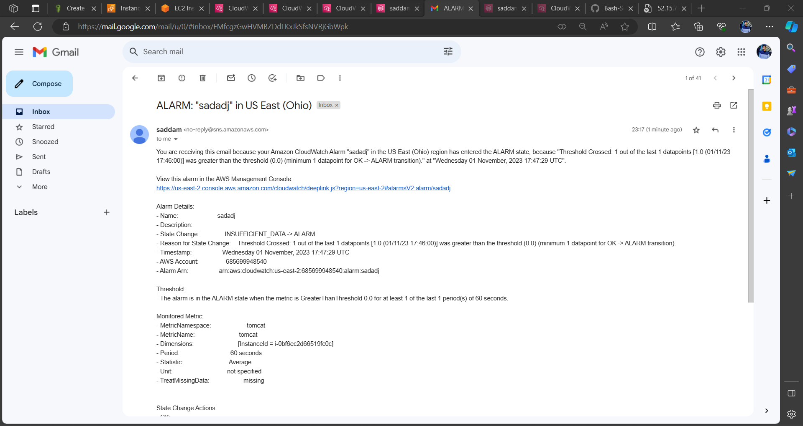

# **6) Create Dashboard and monitor nginx service to send the alert if nginx is not running.**

Launch one instance.  
install nginx   
start nginx service  
add nginx monitoring script to create metric in clous watch  
configure was cli in ec2  
run the bash script  
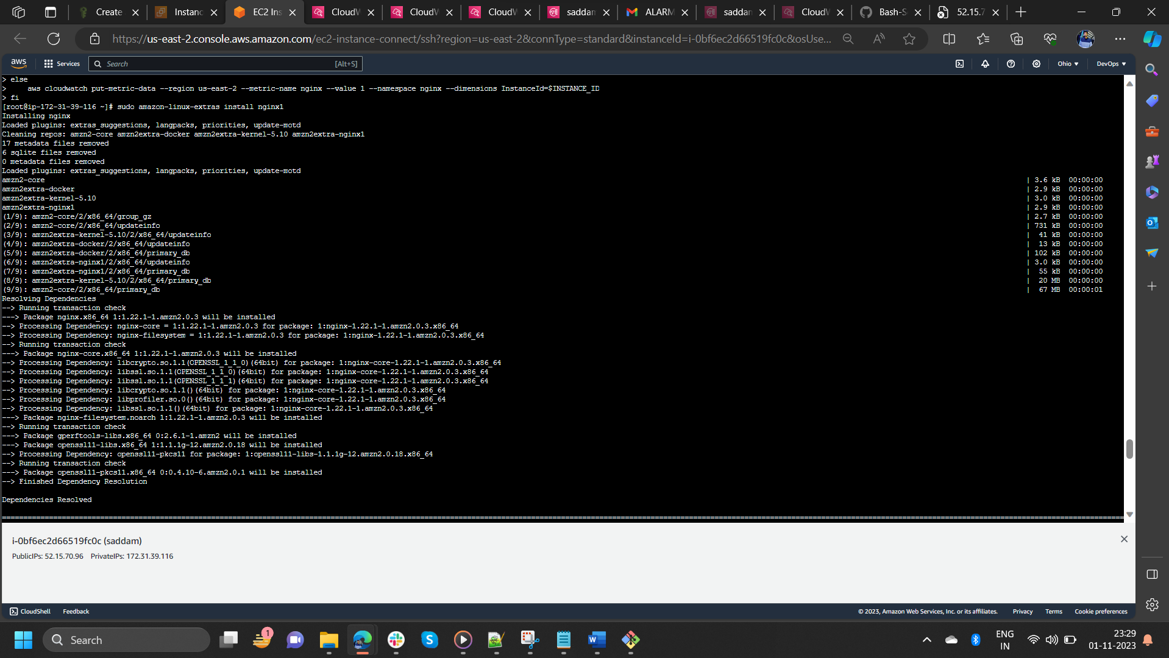 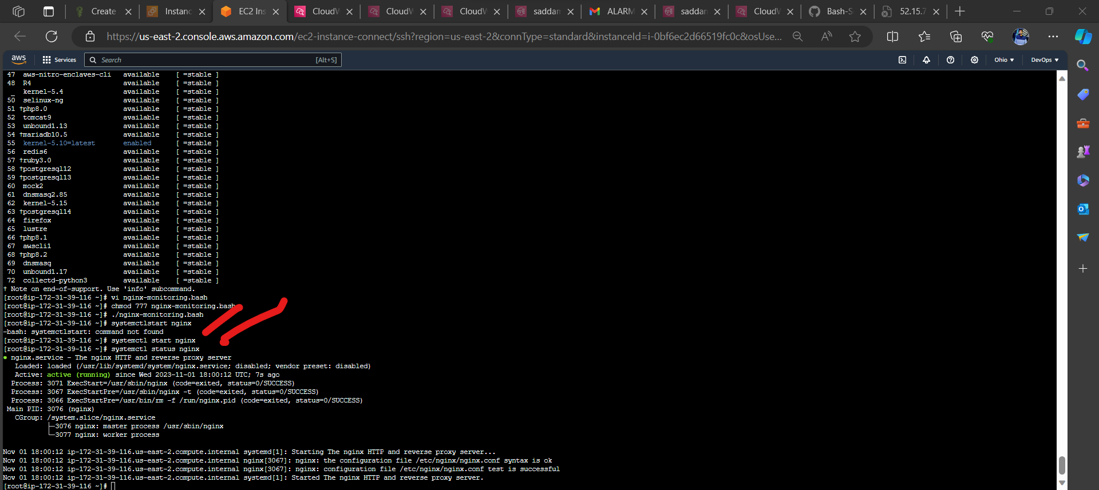 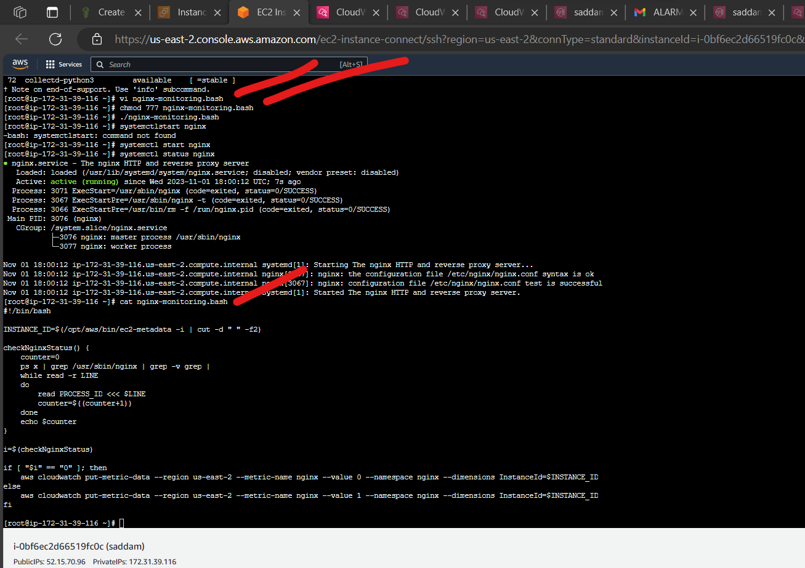  
login to AWS console and navigate to CloudWatch.  
select metrics  
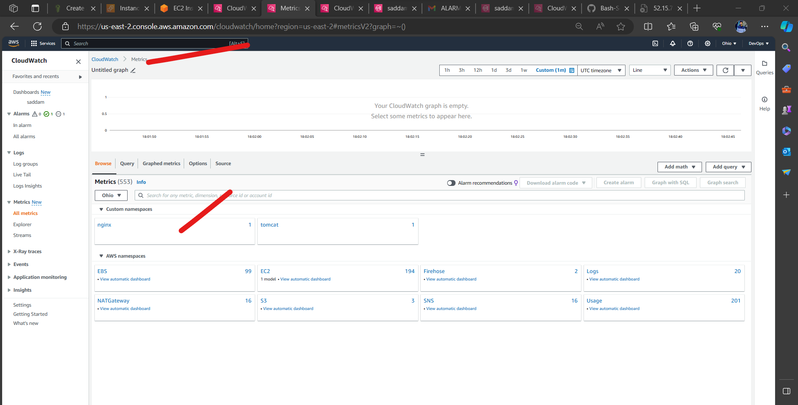

Select nginx and create a Custom dasboard.

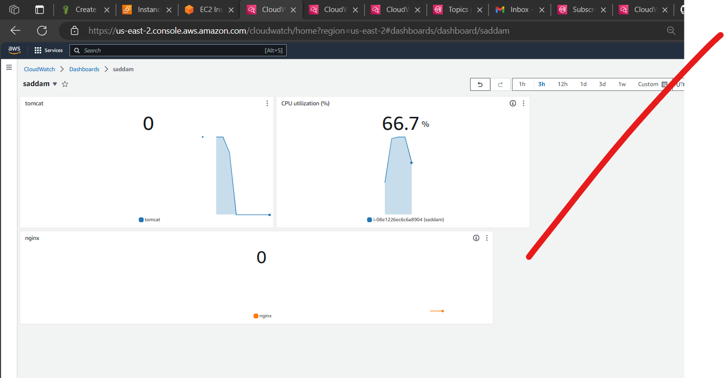  
result

